Multi-Agency Child Exploitation
Protocol
March 2021
Document Control
Date Revision Due: March 2024
Revision History | Version | Changes made | Author
March 22 |  | Oliver Foxell
Sep 22 |  | Added to website Oct 2022 CH

Contents

Introduction 3
Who is this protocol for? 3
What is Child Exploitation? 3
What is the Missing and Exploitation Hub? 4
What is the Multi-Agency Child Exploitation Meeting? (MACE) 6
What are National Referral Mechanisms (NRMs)? 6
Appendix 1- Warning Signs and Vulnerabilities Checklist 8
Appendix 2 – Child Exploitation Indicator Tool 10
Appendix 3- Multi-agency risk assessment and plan 18
Appendix 4- Appropriate Language 20
Appendix 5 - Staff Guide when implementing in case work………..……..……………………………………………………………………27

Introduction
Child Exploitation, whether sexual or criminal, is child abuse. Children who are exploited face significant harm to their physical, emotional and psychological health and well-being. The effects of trauma experienced through exploitation can be cumulative and can require continued ongoing support to recover from throughout the child’s lifetime and into their adult years.
Agencies across Buckinghamshire are committed to safeguarding children and young people from being sexually and / or criminally exploited, and children are recognised as victims of abuse.
This protocol aligns with local arrangements to safeguard children and sets out a clear pathway by which to ensure all organisations work together to provide the best service possible for children and young people either at risk or exploitation or who have experienced exploitation in Buckinghamshire.
An overarching term of Child Exploitation will be used throughout this protocol to encompass both criminal and sexual exploitation of children.

Who is this protocol for?
This protocol is to support professionals to understand how to access support for children where there are concerns regarding exploitation. This is applicable to external professionals and local authority staff.

What is Child Exploitation?
Children are victims first
It is often the case that children do not perceive themselves to be victims, as they consider they have acted voluntarily or that the exploiter is their friend. Peer on Peer exploitation is commonplace and often unrecognised as exploitation by the victim. The reality is that their behaviour is not voluntary or consenting, and every child in this situation needs to be considered a victim first.
Child exploitation can take many forms including but not limited to;
- Grooming is when someone gets close to a child in order to abuse them. This can happen online or face-to-face, and it can be done by strangers or someone familiar. Groomers will hide their true intentions and may spend a long time gaining the child’s trust before the abuse starts.
- Sexual exploitation is when boys or girls are tricked or forced into performing sexual acts, possibly with multiple perpetrators of abuse. They might receive gifts, money or affection, be given alcohol or drugs, or be tricked into believing they are in a consensual relationship.
- Criminal exploitation is when young people are forced to commit crimes that benefit the exploiter. They might be forced to beg, to steal, to sell pirate DVDs, or to grow or deal drugs. ‘County Lines’ is when gangs and drug dealers use children to transport and sell drugs across the country, using ‘county line’ mobile phone numbers for different regions.
- Forced or child marriage is when a young person is forced to marry against their will. It can be a form of modern slavery as the young person is treated as something to be traded, and then used for sex and housework.
- Domestic servitude is when a child is confined to a home to do housework such as cooking, cleaning, and childcare.
- Forced labour is when a young person is forced to work for little or no money. It could happen anywhere, but the commonly reported places are car washes, nail bars, restaurants or takeaways, building sites and farms.
Definitions for Child Sexual and Criminal Exploitation
The nationally agreed definitions below are utilised across Buckinghamshire for sexual and criminal exploitation:
Child Sexual Exploitation
Child Sexual Exploitation is a form of child sexual abuse. It occurs where an individual or group takes advantage of an imbalance of power to coerce, manipulate or deceive a child or young person under the age of 18 into sexual activity.
(a) In exchange for something the victim needs or wants, and/or
(b) For the financial advantage or increased status of the perpetrator or facilitator.
The victim may have been sexually exploited even if the sexual activity appears consensual. Child Sexual Exploitation does not always involve physical contact; it can also occur through the use of technology.
(Home Office 2017)
Child Criminal Exploitation
Child Criminal Exploitation occurs where an individual or group takes advantage of a person under the age of 18 and may coerce, manipulate or deceive a child or young person under that age into any activity.
(a) In exchange for something the victim needs or wants, and/or
(b) For the financial advantage or increased status of the perpetrator or facilitator, and/or
(c) Through violence or the threat of violence.
The victim may be exploited even if the activity appears consensual (i.e. moving drugs or the proceeds of drugs from one place to another).
Child Criminal Exploitation does not always involve physical contact; it can also occur through the use of technology.
(Home Office 2018)
Buckinghamshire Missing and Exploitation Hub have undertaken to work with young people up to the age of 25.

What is the Missing and Exploitation Hub?
Buckinghamshire Council and partners have committed resources from their agencies to ensure a collective approach is adopted across the county when managing child exploitation.
There is a clear link between children who are missing and exploited;
“Children who run away or go missing from home, care or education are recognised as being more at risk of being targeted as a victim of exploitation. Evidence is clear that a missing child is believed to be at risk from Child Exploitation, irrespective of the length of time they are away from home or a caring environment (Plass, 2007; CEOP, 2011b)”
The Missing Children Practice Guidance outlines the work that the Hub undertakes to safeguard children who have been reported as missing from home, care or education.
The Missing and Exploitation Hub will have varying degrees of involvement in a child(ren)’s case, the rationale for which will be clearly noted on child’s social care record and the Youth Offending Service database. All relevant agencies will be made aware of the decision and rationale for the involvement of and specific role the Hub will carry out.
The Missing and Exploitation Hub is made up of;
- Buckinghamshire Children’s Social Care
- Thames Valley Police
- Youth Offending Service
- Barnardos RU Safe
- Buckinghamshire Healthcare Trust
- The Hub also links with the Education Safeguarding Advisory Service.

Partners work together to;
- Raise awareness of exploitation through training
- Offer expert consultation and analysis
- Provide specialist input to care planning for children
- Help identify contextual risks and “map” known intelligence
- Gather and share intelligence from within and out of county
- Collate data to create a local understanding of need
- Support completion of and track National Referral Mechanism Forms (NRMs)
- Increase understanding of geographical “hotspots”
- Keep up to date with current practice research and themes.
How to refer into the Missing and Exploitation Hub
Should partners have concerns regarding the exploitation of a child, the following process should to be followed;
For those not known to Children’s Social Care;
- A Multi-Agency Referral Form (MARF) needs to be completed.
- The form needs to cite what the concerns are in relation to exploitation (for support on signs of exploitation see Appendix 1).
- A Child Exploitation Indicator Tool should also be completed in conjunction with the MARF (See Appendix 2 for CE form).
- This will be progressed for decision by the Multi-Agency Safeguarding Hub (MASH) which may result in an assessment or support from Early Help Services.
- If an assessment determines a need for the Exploitation Hub to become involved, the Child Exploitation Indicator Tool will be sent by the MASH / Assessment team along with any additional information.
For those already open to social care;
- Partners should contact allocated Social Worker and discuss/ request completion of the Child Exploitation Indicator Tool
- A Child Exploitation Indicator Tool will need to be completed on LCS (This is being requested as an update from LCS- 04.02.21)
- The Exploitation Hub can be contacted to offer consultation and discuss initial concerns.
- This tool will need to be sent to exploitationreferral@buckinghamshire.gov.uk.
If you are unsure if a child is known to Social Care or not, please contact the MASH who will either advise you to complete a MARF and CE tool, or refer you to the relevant team.
What happens next?
The referral will be screened at the Hub bi-weekly touchdown meeting. The referrer may be asked to provide further information if required.
The child will then be added to the next Multi-Agency Child Exploitation Meeting (MACE) agenda.
The Hub will contact you and agree any immediate actions that may need to be considered to support the child / family.
The child will then be discussed at MACE where a Multi-Agency Risk Assessment and Plan (Appendix 3) will be considered. This will form part of any statutory plan and does not replace it.

What is the Multi-Agency Child Exploitation Meeting? (MACE)

Child Exploitation takes place across local communities and information and intelligence known to statutory and voluntary sector agencies should be used to highlight the threat, establish and reduce risk. An improved picture of intelligence will enable effective action in a greater number of cases of child exploitation, thereby reducing the harm that would otherwise be caused to the young victims and their families.
The MACE meeting provides the framework to allow regular information sharing and action planning to tackle child exploitation across Buckinghamshire.
Who attends MACE?
The MACE meetings are co-chaired by Thames Valley Police and the Local Authority and are attended by all relevant partner agencies. Additional representation from other agencies including CAMHS and drug and alcohol services also attend where required.
How does MACE work locally?
- The referrer will be invited to present their child, and their concerns to partners.
- During the meeting any community risk issues and strengths will be explored.
- Actions partners can take to support disrupting activity of the exploiters will also be considered.
- The aim is to support any existing plans for the children that may prevent them from being further exploited.
- Any information gathered will also serve to increase understanding of the local threat of exploitation and resource, such as outreach in specific areas where a need is identified.
- Review dates will be agreed with a view to remove the child from the panel when deemed suitable.
- A Multi Agency Risk Assessment and Plan (Appendix 3) will be developed within the meeting.

What are National Referral Mechanisms (NRMs)?
It is the statutory duty of the Local Authority to complete the National Referral Mechanism (NRM) for children where it is believed they are being exploited. The NRM is a framework for identifying and referring potential victims of modern slavery and ensuring they receive the appropriate support. The mechanism supports both Children and Adults suspected of being exploited.
It is important to note that children under the age of 18 do not have to consent to being referred and must be first safeguarded and then referred into the NRM process. All children where there is a concern of exploitation should be referred into the NRM.
How do I refer into the NRM?
A referral form is completed online via the Home Office. The Exploitation Hub will complete an NRM referral form in collaboration with the professional who is working with the child. This is important as the detailed information and knowledge of the issues will be best known to the professional who is working with the child. The Home Office has provided a detailed guidance on the NRM process
- Where an NRM is needed, a meeting will need to be arranged with the Hub so information from your Child Exploitation Indicator Tool and any additional information can be gathered to populate the NRM form.
- The NRM form will be sent from the exploitationreferral@buckinghamshire.gov.uk mailbox.
- This will mean any confirmation and communication will be had with the Hub, but they may need to refer any queries with the worker involved.
- Any decisions will be shared directly with the worker involved.
What does the Home Office do once a referral is made?
- Once a child has been referred into the NRM, the assessing authority (known as the ‘Single Competent Authority’ - SCA) will, within five working days, make a decision as to whether or not there are “reasonable grounds” for believing that the person has been trafficked. This is known as the reasonable grounds’ decision.

- If the SCA decides that there are no reasonable grounds, there is no right of appeal: the only way to challenge this decision is through judicial review in the High Court.

- If reasonable grounds are confirmed the SCA then has a further 45 days to investigate, gather information and provide a “Conclusive Grounds” decision. At this point the decision will be shared as to whether the child is a considered to be victim of modern slavery.

- If they are deemed to be a victim of modern slavery, it does not mean the child will get anything “extra” in terms of support (adults do). It is the Local Authority’s duty to manage and safeguard the child.

- However, if a child is a victim of modern slavery and an offence is committed, the Crown Prosecution Service (CPS) may say they will not charge due to the status of “victim” or the judge may choose to adjourn sentencing to take into consideration the outcome of the conclusive grounds decision.

Appendix 1- Warning Signs and Vulnerabilities Checklist

There are common vulnerability factors in children that can lead to them being more likely to be exposed to exploitation, and common signs and behaviours displayed by those who are already being exploited.
The following are typical but not exclusive vulnerabilities in children prior to abuse:
• Living in a chaotic or dysfunctional household (including parental substance misuse, domestic violence, parental mental health issues, parental criminality).
• History of abuse (including familial child sexual abuse, risk of forced marriage, risk of ‘honour’-based violence, physical and emotional abuse and neglect).
• Recent bereavement or loss.
• Gang association either through relatives, peers or intimate relationships (in cases of gang associated CE only).
• Attending school with children who are exploited.
• Learning disabilities.
• Unsure about their sexual orientation or unable to disclose sexual orientation to their families.
• Friends with children who are exploited.
• Lacking friends from the same age group.
• Living in a neighbourhood where organised crime groups/gangs are operating.
• Living in residential care.
• Living in a hostel, bed and breakfast accommodation, a foyer or homeless.
• Low self-esteem or self-confidence.
• Young carer.
The following signs and behaviour are generally seen in children who are exploited:
• Regularly missing.
• Parents / Care not reporting young person missing.
• Drug or alcohol misuse.
• Has extra money/new items/‘gifts’ that cannot legitimately be accounted for/received from unknown sources.
• Change in physical appearance or behaviour.
• Pregnancy, termination or repeat testing for sexually transmitted infections.
• Young person has been coerced to take/share indecent images.
• Arrested/Involved in criminality.
• Found / travelling out of local area.
• Multiple mobile phones.
• Young person feels indebted to an individual or group.
• Family or young person having to move or leave their home.
• Items missing from home.
• Young person carrying / concealing weapons.
• Services have not been able to engage with child.
• Self-harm indicators and/or mental health concerns and/or suicidal thoughts/attempts.
• Injuries – evidence of physical or sexual assault.
• Relationship breakdown with family and or peers.
• Association with older and/or risky peers.
• Change in education attendance/change in education provider/missing from education/non-attendance in education.
Any child displaying several vulnerabilities from the above lists should be considered to be at risk of exploitation. However, children without pre-existing vulnerabilities can still be exploited so, any child showing risk indicators in the second list, but none of the vulnerabilities in the first list, should also be considered as a potential victim.

Appendix 2 – Child Exploitation Indicator Tool

Buckinghamshire BSCB
Child Exploitation Indicator Tool

Guidance
This Indicator Tool aims to help practitioners focus on the specific exploitation indicators and determine whether further investigations are needed by Children’s Social Care and Thames Valley Police. This tool therefore informs both assessment of need and referrals to Children’s Social Care. This tool should be attached to your Children’s Social Care referral regarding a potential CSE or other exploitation case.
The Exploitation Indicator Tool can be used by any professional working with children under the age of 18, whilst we appreciate some adolescents prefer the term young people for the purpose of this document, we will refer them to children.
Often children themselves do not recognise themselves as victims or that they are being groomed, and as a result, disclosures of such abuse can be unlikely. Therefore, this indicator tool aids the identification of exploitation.
Practitioners need to exercise their own professional judgment when completing the tool because factors such as the child’s age, any additional vulnerabilities, their history etc. may mean that they are more vulnerable to exploitation. Professional judgment also includes capturing concerns about which they have some evidence AND concerns based on ‘their gut feeling’. Staff should differentiate between the two and explain this in the ‘comments/evidence/description’ sections.
Once completed, where child exploitation is suspected the worker should follow local safeguarding procedures. Remember, Children’s Social Care is responsible for assessing the level of risk to children. Should the referral not meet Children’s Social Care’s threshold, other support options will be considered including Early Help and referrals to appropriate services.
If you suspect anyone is in immediate danger, call the Police on 999.
Please note that this document will be shared with statutory agencies in order to safeguard children with the strict understanding that it is only used for that purpose.
Child’s Details
Child’s name:
Date of birth:
Childs Address:
Ethnicity:
School / College:
Is this child looked after? | Yes c No c
Do they live in residential care? | Yes c No c
Are they placed at a distance? | Yes c No c

Your Details
Your name
Job title
Contact details
Which agency are you from?
Date completed:

Information Sharing and Disclosure
Is child aware that this tool has been completed? | Yes c No c
Are Parents/Carers aware that this tool has been completed? | Yes c No c
Who else has contributed to the completion of this indicator tool? (child, parent/carer, school…)

Has the child made a disclosure of exploitation (abuse)?
Current c Yes c No c If ‘Yes’ you must refer to Children’s Social Care immediately
Historic c Yes c No c If ‘Yes’ you must refer to Children’s Social Care to determine current risk
Are the people who may be grooming or exploiting the young person:
Known to the child? | Yes c No c Unknown c
A family member? | Yes c No c Unknown c
(if you answer Yes to either of the above questions please state who this person is)

Names of the child’s friends/sibling/other who you think might be affected by exploitation also:

Risk Indicators
- Health Domain Health to check | Yes (Y) / No (N) | Current (C) / Previous (P)
  - Physical injuries such as bruising suggestive of either physical or sexual assault
  - Sexually transmitted infection (STI), including recurring infections or multiple STI's
  - Pregnancy and / or seeking a termination/emergency contraception
  - Accessing contraception outside of ‘normal’ amounts.
  - Poor self-image and low self-esteem
  - Self-harming
  - Thoughts of or attempted suicide
  - Eating disorder and /or weight gain/loss
  - Evidence of misuse of drugs / alcohol, including associated health problems
  - Physical and/or learning disability or difficulty
Health Comments/Evidence/Description of ‘YES’ indicators
E.g. Indicator 1.8 – child/young person is attending substance misuse project and has disclosed heavy cannabis use

- Behaviour Domain | Yes (Y) / No (N) | Current (C) / Previous (P)
  - Risk taking behaviour without recognising the impact or consequences
  - Truancy / at risk of exclusion / missing education / on reduced timetable or considerable change in performance at school
  - Volatile behaviour exhibiting extreme array of mood swings or abusive language which is unusual for the child
  - Aggressive or violent including to animals, parents, siblings, teachers or peers
  - Becoming angry, hostile if any suspicions or concerns about their activities are expressed
  - Detachment from age-appropriate activities
  - Secretive behaviour
  - Change in appearance (not including weight changes)
  - Young offender or anti-social behaviour including petty crime
  - Changes in relationships with families or family members
Behaviour Comments/Evidence/Description of ‘YES’ indicators

- Grooming Domain | Yes (Y) / No (N) | Current (C) / Previous (P)
  - Entering or leaving vehicles driven by unknown adults
  - Excessive use of mobile phones including receiving calls late at night
  - Possession of a second mobile phone or sim card
  - Exposing or recruiting other children into exploitative situations
  - Seen in adult places (i.e. pubs and clubs) or venues known to be used for exploitation or criminal activity
  - Unexplained relationships with older adults
  - Associating with other children who are known to be exploited, including in school
  - Sexual relationship with a significantly older person
  - Disclosure of sexual /physical assault followed by withdrawal of allegation
  - Phone call, texts or letters from unknown adults
  - Mobile phone being answered by unknown adult / person
  - Inappropriate use of the Internet and forming relationships, particularly with adults (they may appear to be peers), via the Internet.
  - Social activities with no plausible explanation of the source of necessary funding
  - Having keys to premises other than those they should have including hotel key cards
  - Possession of money, clothes, accommodation or other expensive items with no plausible explanation
  - Adults loitering outside the child’s usual place of residence or school
  - Persistently missing from home or placement for different periods, including overnight or returning late
  - Returning after having been missing and being secretive about where they have been and who they were with
  - Returning after having been missing looking dirty, disheveled, tired, hungry, thirsty
  - Abduction or false imprisonment
  - Coerced into sexual activity
  - New contacts with people outside of town
Grooming Comments/Evidence/Description of ‘YES’ indicators

- Family and Social Domain | Yes (Y) / No (N) | Current (C) / Previous (P)
  - A family member or known associate working in the adult sex trade or criminal/drug activity
  - History of physical, sexual and / or emotional abuse; neglect
  - Witness to domestic violence/abuse at home
  - Parental difficulties; drug and alcohol misuse, mental health problems, physical or learning difficulty. Child is a young carer.
  - Pattern of street homelessness or sofa surfing
  - Living in hostel, B & B or Foyer accommodation
  - Conflict at home around boundaries, including staying out late.
  - Living in a gang affected neighbourhood
  - Recent bereavement, loss, family separation and/or family breakdown.
  - Are parents protective?
  - Gang association either through relatives, peers or intimate relationships
  - Intelligence to suggest that they carry weapons
  - Lacking friends their own age
  - There are cultural factors that impacts their vulnerability
  - Going missing with other children
Family and Social Domain Comments/Evidence/Description of ‘YES’ indicators

- E Safety Domain | Yes (Y) / No (N) | Current (C) / Previous (P)
  - Evidence of vulnerability through internet or social networking sites
  - Concern that inappropriate images of a child are being circulated via the internet / phones
  - Concern that the child is being coerced/bribed/threatened to provide explicit images/engage in inappropriate online activity
  - Concern that the child is being paid for sexual acts online
  - Accessing on-line dating/‘hook-up’ sites
  - Unexplained increased use of social networking, shared gaming sites and / or receiving rewards/credits.
  - Going online during the night
  - Being secretive using mobile phone for accessing websites etc. including unwillingness to share / show online or phone contacts
  - Concern that a child is having an online ‘relationship’
  - Concerns that a child’s online friendship has developed into an offline ‘relationship’
E-Safety Comments/Evidence/Description of ‘YES’ indicators

When considering exploitation, the following domains are helpful to consider:
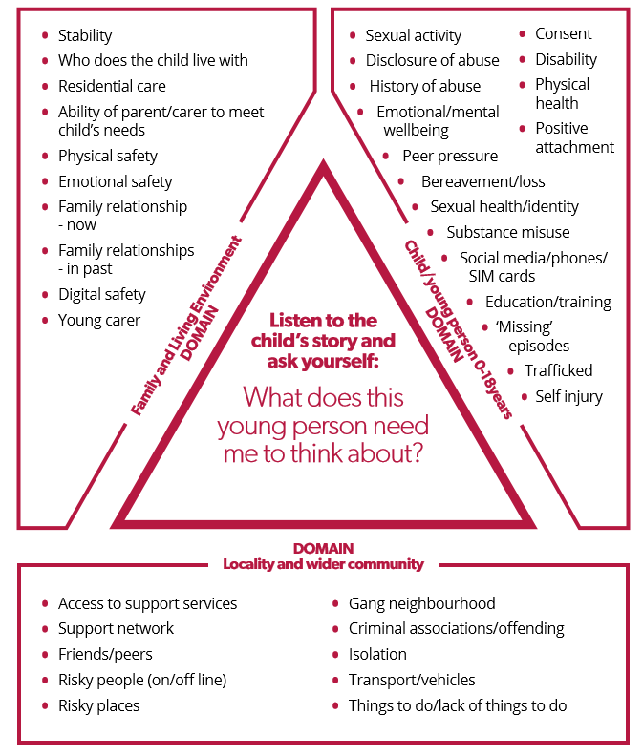
Summary of Any Concerns
It is important you complete all of this section
Total number of concerns identified:
Current
Historic
Your analysis and overview (a few sentences to indicate your thinking):

Specific planned or completed actions as result of tool completion:

Which agencies/workers are involved with this child/family?
I
Has an NRM been completed previously? Please attach / provide details

What type of exploitation has been identified through completion of the indicator tool;
CSE currently not a factor at this time/concerns relate to age appropriate behaviors
Evidence² of vulnerability to sexual exploitation
Evidence² of being groomed (including on-line) or targeted for the purposes of sexual exploitation
Evidence² of being groomed into membership of a criminally active gang
Evidence² that child is being sexually exploited
Evidence² of drugs exploitation
Evidence² of other modern day slavery

Appendix 3- Multi-agency risk assessment and plan

Multi Agency Risk Assessment and Plan
NB. To be considered in conjunction with Child Exploitation Indicator Tool and NRM
Child’s Details
Child’s name:
Date of birth:
Ethnicity:
School / College:
Is this child looked after? | Yes c No c
Do they live in residential care? | Yes c No c
Are they placed at a distance? | Yes c No c

Professional Presenting;
Name
Job title
Contact details
Date presented

What are the risks?
Are these imminent or future risks?
Who are “of concern” to professionals in terms of associates / peers?
What strengths exist?
Who does the child have a meaningful relationship with?
What do we know about push and pull factors?

Pull factors, are factors which can pull a child towards exploitation. This can be children performing tasks for others resulting in them gaining things such as, accommodation, food, gifts, status or a sense of safety, money or drugs. Often the hook is through the perpetrator supplying Class B drugs such as cannabis to the child or young person.

Push factors are factors which push a child away from their environment and closer towards exploiters. Children escaping from situations where their needs are neglected and there is exposure to unsafe individuals, where there is high family conflict or the absence of a primary attachment figure.

What current plans are in place to manage the presenting risks / vulnerabilities?
What additional support / plan is needed?
What can partner do / are doing to disrupt activity?
What else might be going on we need to be mindful of? Community / police intelligence?
Any other specific actions required?
If child is no longer going to be heard at panel, please note here rationale for decision.
When review will be held and why?

Review meeting date:
Review actions
Have risks reduced / increased and why?
Additional support / measures to be considered?

Remember a child can be re-referred into MACE should concerns arise or further support is needed from the partnership

Appendix 4- Appropriate Language

APPROPRIATE
LANGUAGE:
CHILD SEXUAL
AND/OR CRIMINAL
EXPLOITATION

GUIDANCE FOR
PROFESSIONALS

Author:
Date:
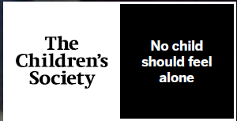
How to Use this document
This document can be used by professionals when discussing the exploitation of children and young people, including when escalating intelligence and delivering training. The document can be read at the beginning of strategy meetings, multi-agency meetings, or other settings where professionals might be discussing children and young people who are at risk of
exploitation

ABOUT APPROPRIATE LANGUAGE IN RELATION TO CHILD SEXUAL AND/OR CRIMINAL EXPLOITATION

It is imperative that appropriate terminology is used when discussing children and young people who have been exploited or are at risk of exploitation. Language implying that the child or young person is complicit in any way, or responsible for the crimes that have happened or may happen to them, must be avoided.
Language should reflect the presence of coercion and the lack of control young people have in abusive or exploitative situations, and must recognise the severity of the impact exploitation has on the child or young person. Victim-blaming language may reinforce messages from perpetrators around shame and guilt. This in turn may prevent the child or young person from disclosing their abuse, through fear of being blamed by professionals. When victim-blaming language is used amongst professionals, there is a risk of normalising and minimising the child’s experience, resulting in a lack of appropriate response.
GUIDANCE FOR USING APPROPRIATE LANGUAGE

The following table outlines terms that should not be used when discussing or recording issues of child sexual exploitation, and includes a list of appropriate alternative phrases.

Inappropriate Term | Suggested Alternatives
Putting themselves at risk  This implies that the child is responsible for the risks presented by the perpetrator and that they are able to make free and informed choices. | - The child may have been groomed.  - The child is at an increased vulnerability of being abused and/or exploited.  - A perpetrator may exploit the child’s increased vulnerability.  - The child is not in a protective environment.  - The situation could reduce/adversely effect the child’s safety.  - The location is dangerous to children.  - The location/situation could increase a perpetrator’s opportunity to abuse them.  - It is unclear whether the child is under duress to go missing.  - There are concerns that the child may be being sexually abused.  - It is unclear why the child is getting into cars.  - There are concerns that there is a power imbalance forcing the child to act in this way.  - There are concerns regarding other influences on the child.
Sexual activity with…  This implies consensual sexual activity has taken place. If it occurs within an abusive or exploitative context this term is not appropriate. | - The child has been sexually abused.  - The child has been raped.  - There are reports of sexual abuse.  - The child has described sexual activity, however concerns exist that they child may have been groomed and/or coerced.
Sexually active since [age under 13]  A child under 13 cannot consent to sex and is therefore being abused. This should be reflected in the language used. | - The child has been raped.  - The child has been/may have been sexually abused.  - Concerns exist that the child may have been coerced, exploited, or sexually abused.
Inappropriate Term | Suggested Alternatives
Has been contacting adult males/females via phone or internet  This implies that the child or young person is responsible for the communication and does not reflect the abusive or exploitative context | - Adult males/females may have been contacting the child.  - The child may have been groomed.  - There are concerns that the adult is facilitating communication with a child/there has been contact between.  - The child is vulnerable to online perpetrators.  - There are concerns that others may be  - using online technology to access or abuse  - the child.  - Adults appear to be using a range of methods  - to communicate with the child.
Offering him/her drugs seemingly in return for sex  This implies that the child or young person is responsible for the abuse and has the capacity to make a free and informed choice. It does not recognise the  abusive or exploitative context. | - The child is being sexually exploited.  - There are concerns that the child has been raped.  - Perpetrators are sexually abusing the child.  - The child is being sexually/criminally abused.  - The child’s vulnerability regarding drug use is being used by others to abuse them.  - The perpetrators have a hold/influence over the child by virtue of the fact that they have a drug dependency.
In a relationship with…  This implies that the child or young person is in a consensual relationship and does not reflect the abusive or exploitative context. | - The young person says that they are in a relationship with a person and there are concerns about that person’s age, the imbalance of power, exploitation and/or offending.  - The young person has been/is being groomed, exploited and controlled.
Inappropriate Term | Suggested Alternatives
Involved in CSE  This implies there is a level of choice regarding the child being abused. A five year old would never be referred to as being involved in sexual abuse for the same reasons. | - The child is vulnerable to being sexually exploited.  - The child is being sexually exploited.
Promiscuous  This implies consensual sexual activity has taken place. Promiscuous is a judgemental term which stereotypes and labels people. It isn’t appropriate in any context when discussing children and young people, but particularly if it occurs within an abusive or exploitative context. | - The child is vulnerable to being sexually exploited.  - The child is being sexually exploited.
Prostituting themselves  This implies that the child or young person is responsible for the abuse and has the capacity to make a free and informed choice. It does not recognise the abusive or exploitative context.  Changes in legislation have meant that child prostitution is no longer an acceptable term and should never be used. | - The child is vulnerable to being sexually exploited.  - The child is being sexually exploited.
Boyfriend/girlfriend  This implies that the child or young person is in a consensual relationship and does not reflect the abusive or exploitative context.  Children have been challenged in court with practitioners recordings where a practitioner has referred to the perpetrator as the child’s boyfriend or girlfriend. | - The young person says that they are in a relationship with a person and there are concerns about that person’s age,/maturity/development that exploits the imbalance of power, exploitation and/or offending.  - The young person has been/is being groomed, exploited and controlled.
Inappropriate Term | Suggested Alternatives
Drug running – He/she is drug running  This implies that the child or young person is responsible for the exploitation and has the capacity to make a free and informed choice. It does not recognise the abusive or exploitative context. | - Child criminal exploitation (CCE).  - The child is being criminally exploited.  - The child is being trafficked for purpose of criminal exploitation.
Recruit/run/work  This implies that the child or young person is responsible for the exploitation and has the capacity to make a free and informed choice. It does not recognise the abusive or exploitative context. | - The child is being criminally exploited.
He/she is choosing this lifestyle  This implies that the child or young person is responsible for the exploitation and has the capacity to make a free and informed choice. It does not recognise the abusive or exploitative context. | - The child is being criminally exploited.  - The child is being sexually exploited.
Spending time/associating with ‘elders’  This implies that the child or young person is responsible for the exploitation and has the capacity to make a free and informed choice. It does not recognise the abusive or exploitative context. | - The young person says that they are friends with a person and there are concerns about that person’s age, the imbalance of power, exploitation, offending/maturity, development.  - The young person has been groomed, exploited, controlled.  Note: If the elder is under the age of 18  years old, this will need to be considered using child protection processes..
Inappropriate Term | Suggested Alternatives
Offering him/her drugs seemingly in return for sex or to run drugs  This implies that the child or young person is responsible for the exploitation and has the capacity to make a free and informed choice. It does not recognise the abusive or exploitative context. | - The child is being sexually/ criminally exploited.  - The child is being criminally exploited through drug debt.  - There are concerns that the child has been raped as they do not have the freedom or capacity to consent.  - Perpetrators are sexually abusing the child.  - The child is being sexually abused.  - The child’s vulnerability regarding drug use is being used by others to abuse them.  - The perpetrators have a hold over the child by the fact that they have a drug dependency.

THIS GUIDANCE HAS BEEN GRATEFULLY PRODUCED WITH SUPPORT AND MATERIALS DEVELOPED BY NWG AND LAWRENCE JORDAN, SOCIAL WORKER, MILTON KEYNES
IN COLLABORATION WITH THE CHILDREN’S SOCIETY, VICTIM SUPPORT AND THE NATIONAL POLICE CHIEFS’ COUNCIL

Appendix 5 - Contextualised Safeguarding - Staff Guide

Please note this is not an exhaustive list of things to consider and you are encouraged to speak to the Exploitation Hub for further support if needed.

What is Contextual Safeguarding?

Contextual Safeguarding is an approach to understanding, and responding to, young people’s experiences of significant harm beyond their families. Traditional approaches to protecting children/young people from harm have focussed on the risk of violence and abuse from inside the home, usually from a parent/carer or other trusted adult and don’t always address the time that children/young people spend outside the home and the influence of others on young people’s development and safety.
Contextual safeguarding recognises the impact that the different relationships young people form in their neighbourhoods, schools and online have on their lives, and consequently their safety. This approach seeks to identify and respond to harm and abuse posed to young people outside their home, either from adults or other young people considering how different interventions can change the processes and environments, to make them safer.

To understand how we work in Buckinghamshire, please refer to the Exploitation Protocol – See below.

When I am working with a child at risk of exploitation, have I considered…?

Area to consider | What is it? | How to consider in casework?
Have I consulted with the Exploitation Hub at the earliest possible opportunity to explore what my concerns are re: exploitation? Refer to Exploitation Protocol. | The hub is there to offer you support and guidance on at the earliest opportunity you identify concerns of exploitation. | Hub has a duty worker on every day and can offer advice, support and guidance by way of a consultation. This is recorded on the system by the Exploitation Hub worker providing guidance on how best to progress the case. This could include support to progress a referral into MACE, advice on further information required or guidance on how to refer into the National Referral Mechanism (NRM).  Prompt questions  Am I concerned this young person is susceptible to being exploited?  Do they display certain vulnerabilities – e.g learning needs?  Would it be helpful to have a reflective discussion with someone who has expertise / knowledge in this area of contextual safeguarding?
Have I explored Push and Pull factors which are linked to children who are exploited? | Pull factors, are factors which can pull a child towards exploitation. This can be children performing tasks for others resulting in them gaining things such as, accommodation, food, gifts, status or a sense of safety, money or drugs. Often the hook is through the perpetrator supplying Class B drugs such as cannabis to the child or young person.  Push factors are factors which push a child away from their environment and closer towards exploiters. Children escaping from situations where their needs are neglected and there is exposure to unsafe individuals, where there is high family conflict or the absence of a primary attachment figure. | When considering risk factors for children it is important to understand these as “push and pull factors” as it allows the professional to gain insight into why the young person may end up being exploited and how they may be able to achieve these “pull” factors by alternative means.  Prompt questions  For example, have we talked to the child about what will make them feel safe? What is their understanding or definition of safe?  Do they have financial difficulty in their home? (pull factor)  Are they suffering from or witnessing domestic abuse within the family home? (push factor)  Examples of pull factors (not exhaustive list)  Wanting freedom and independence  Being made to feel special by grooming for potential sexual exploitation or child trafficking  Fear of repercussion for self or family if they don’t go  Feeling “wanted”  Examples of push factors (not exhaustive list)  Not feeling accepted or wanted in their environment  Family breakdown  Mental health problems  Low Self esteem
Have I thought about what language I am using to describe the child or the situation? | Secondary Victimisation / Language  Language that victimises and blames children, and often places responsibility to “resolve” the issue of exploitation on the child themselves.  Examples of language used in case work reviewed included;  - “streetwise”  - “drug running”  - “putting herself at risk of exploitation” | Language should reflect the presence of coercion and the lack of control children have in abusive or exploitative situations. Victim-blaming language may reinforce messages from perpetrators around shame and guilt. This in turn may prevent the child from disclosing their abuse, through fear of being blamed by professionals. When victim-blaming language is used amongst professionals, there is a risk of normalising and minimising the child’s experience, resulting in a lack of appropriate response.  Prompt Questions  If someone else was to read the file, would it imply it is the childs “choice” these things are happening?  Have I tried to reframe the language I would use by using the tools below?  Have I linked the risks being identified to the exploiter?  Have I asked what the childs behaviour is trying to communicate?  What is their unmet need based on previous and historical lived experiences and trauma?  Alternatives you can use when writing about children;  Page 20 of the Exploitation Protocol tool offers alternatives  NWG (National Working Group – Exploitation)  Victim Blaming Language - NWG Network  Trauma informed Language  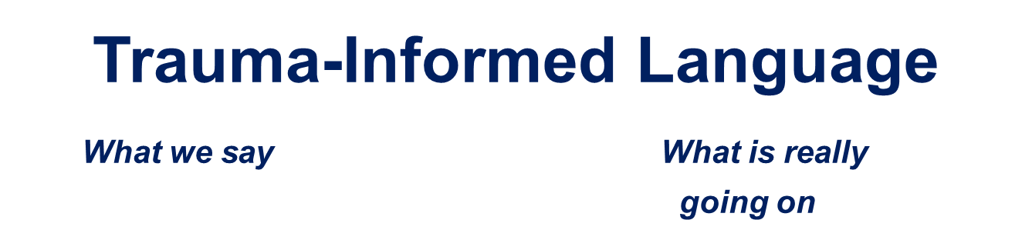  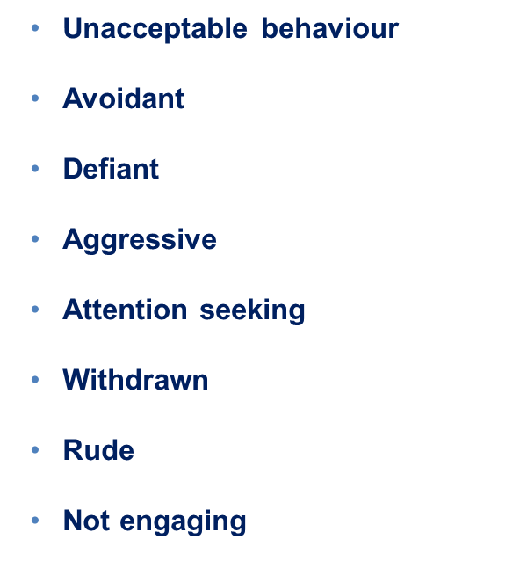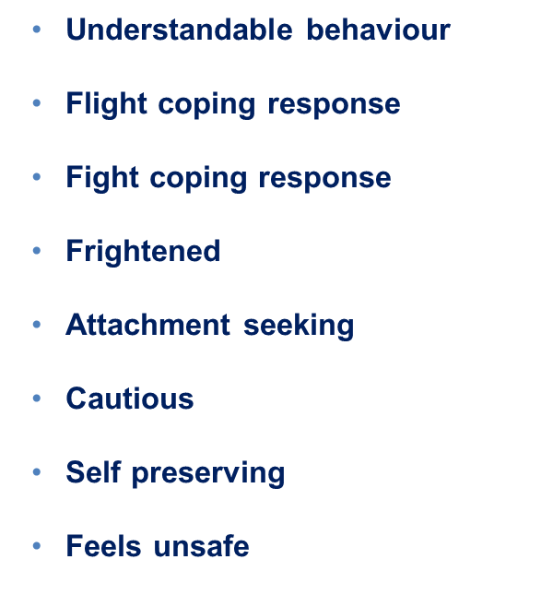
Have I tried to build a “meaningful relationship with this child?” | Depending on the context in which a trusted relationship is being built, it has been suggested that resilience and outcomes can be improved through:  - Encouraging a child to persevere when they are struggling with something  - Giving them a safe and non-judgmental space in which to challenge and explore things that they may be concerned about or not agree with  - Exposing them to alternative possibilities and perspectives, which can help to raise their aspirations and broaden their options  - Enabling a child to realise that the issue they are dealing with is ‘not okay’, and to raise their awareness about the risks associated with a particular situation or behaviour  - Helping children to feel less isolated, as they come to understand that they can share a problem or concern and ask other trusted people to help them overcome it. | A trusted relationship is fundamental to the successful delivery of a service which depends on the effective engagement of a vulnerable child. It has been described as being key to achieving a successful outcome for a child, and to ensuring that children are confident about discussing their concerns and disclosing issues.  Below are some suggestions which may assist in developing meaningful relationships (This is not an exhaustive list)  - Regular contact with the child for “no reason” except to ask how they are through text or call. (This should be outside of statutory visits and any “expected” discussions)  - Asking open ended questions “Tell me about yourself?”  - Reinforcing to child your interest in them as a person “I didn’t know that, that’s really interesting”  - Involving the child in “setting the agenda” for meetings and visits. This means being clear about what is non-negotiable and what is negotiable. For example, “You know I want to come and see you, and will do that, but you tell me what time / day is good for you?”. “What would you like to do when I come and see you?” “You tell me what you want to talk about”  - Suggesting doing something together, before asking questions, and explaining to the child or young person that the most important thing is to “get to know each other”  - Allowing the child or young person to pick perhaps where they see you  - Allowing the child to identify an activity to do with you.  Useful articles  adversity-and-trauma-informed-practice-guide-for-professionals.pdf (youngminds.org.uk)  Trauma and Relationships | Out of Home Care Toolbox (oohctoolbox.org.au)
Have I thought about how my plan reflects appropriate management of risks? | Risk management / safety planning should focus on contextual and external factors within the childs community and extended network of peers and not solely on the child and family themselves. If the risks presented are extra familial – these are the areas that need to be mitigated against.  We need to think about how we can support the child to feel safe which could increase their resilience and be an important factor in extracting them away from exploiters. | Risk and safety planning is key to ensuring young people who are at risk of extra familial harm are kept as safe as possible. This is only achieved through good multi agency working and engagement of partners, both universal and targeted to support the management of risk.  Prompt Questions  Does my case summary show the risk management / safety plan needed for any immediate risks?  Does my CIN / CP plan reflect who is going to support management of risk contextually? Who are the partners that can assist?  Have I referred to MACE? Have I reflected how MACE is supporting / managing contextual risks within my plan?  Is information being effectively shared, and so that each agency can respond appropriately?  Have multi-agency actions been identified and agreed in order to intervene promptly to reduce risk  Has risk to all children been considered – e.g. siblings?  What can other agencies do to support disruption?  Child exploitation disruption toolkit (publishing.service.gov.uk)
Is my plan inclusive of those who can contribute to the contextual intervention? | This means thinking about who can support in the community including parents. Youth workers, professionals at school, places of worship a child may be connected to. | In order to manage extra familial harm, those within the community need to play a key role in supporting delivery of the intervention.  Prompt questions  Have we included the key people in the child's network into the plan?  What do the people who are part of the child's network need to know?  What role could other play in safety planning?  How are we supporting parent / carer / other professionals involved to understand what the risks are?  What role can the education setting play (if child is at school)
Have I demonstrated professional curiosity and thought about the analysis? | Professional curiosity for children who are at risk of / being exploited should demonstrate a need to try and understand the underlying value base of the child. | Professional curiosity should not be limited to only eliciting information from the child / family it may be to probe further with other partners or agencies to gain an increased understanding of the childs context.  Example of professional curiosity  A young person appearing to be under the influence of cannabis, reported by placement as missing. Worker visits child and discusses the missing episode but does not discuss the possible use of cannabis, their views on cannabis and whether they knew where to get it from.  If explored fully with open ended questions this could have provided the worker with opportunities to understand more about what the child understands about exploitation, drug use, what their views were around drug use, if they know how to access it? What did the child understand to mean by the term “gangs” or being “affiliated to gangs”?.  Prompt questions  “How is this childhood trauma manifesting itself in adolescent behaviour that is being seen today?  What can we hypothesise that this may be about? Attachment? Historic neglect? Identity?”  “What is the unmet need for this child?”  E.g. “XX is more susceptible to being exploited because of xxx which happened in their life”. This then would benefit from being underpinned by research regarding exploitation.
Have I sought research to underpin any hypothesis that are being held about push and pull factors? |  | Research can support to underpin hypothesis regarding children that we may hold as professionals involved in trying to understand the child / family and their current and historical context. It is of particular importance in children who are at risk of exploitation due to the everchanging nature of how exploiters will operate to coerce vulnerable children.  Prompt questions  Has the hub been contacted to explore what research may support you to understand more about the risks that are being presented to the child?  Where can I go to get research or learn more?  https://contextualsafeguarding.org.uk/ - free to sign up several resources available  Protecting children from county lines | NSPCC Learning  The Child Safeguarding Practice Review Panel - It was hard to escape - report (publishing.service.gov.uk)
Have I considered submitting a police intel report? | Police intel is essential to submit when thinking about children who are at risk of or have been exploited. | The purpose of police intel can support in identifying information which can be used to rule in or rule out police activity. Each intel report is reviewed by police and located on a specific system, the police can then have a “birds eye” view of risk factors that may be being shared. You can always consult with the Exploitation Hub about the appropriateness of submitting an intel report. Intel reports do not solely need a strategy meeting to take place and can be submitted at any time.  Prompt questions  If the young person has shared some information with me, could this be relevant to wider risk factors presented to the child which I may not be aware of?  Have I consulted with the hub about the appropriateness of submitting intel if I am unsure?  Briefing on what should and should not be submitted – Guidance from TVP  Example Police Intel Form

You can complete the MARF online using the following link Report a concern about a child | Buckinghamshire Council (buckscc.gov.uk).
Report modern slavery - GOV.UK
National referral mechanism guidance: adult (England and Wales) - GOV.UK (www.gov.uk)

