Children’s Services

Local Authority Designated Officer

Annual Report

2022-2023

  - The purpose of this report is to provide an overview of the management of allegations against individuals within the children’s workforce and the role of the LADO Service in Buckinghamshire Council for the period 1 April 2022-31 March 2023

Report Author
Amanda Perkins
LADO Service Manager
Table of Contents

Executive Summary 3
Introduction and background 3
Referral Activity Summary for 2022/23 3
Key issues and challenges for 2022/23 4
What has gone well in 2022/23? 5
What is not working so well/still needed? 5
Recommendations 6
What will be the impact? 6
Introduction and background 8
Staffing and Resources 10
One year on 11
Data Collection and Reporting Framework 12
Summary of referrals 12
Category of Concern 14
Referral Sectors 16
Contacts by sector in which the employee works/volunteers 16
Contacts by Referring Sector 17
Outcomes 18
Outcomes of allegations 18
Timescales for Conclusion 19
Timescales for completed Referrals 19
Overall Contacts Open/Closed 20
Impact and outcomes 21
Multi-agency involvement 21
Feedback 23
Learning/impact from allegations 23
Audit Activity 24
Other LADO Service Activity 25
Conclusion 25
Appendices 25

Executive Summary

Introduction and background

Each Local Authority is required to appoint a designated officer for the management of allegations against adults working with children. The statutory basis of, and the necessity to provide an allegation management service was confirmed in Working Together to Safeguard Children 2013.

All agencies that provide services for children or provide staff or volunteers to work with, or care for children are required to have a procedure in place for managing and reporting allegations against staff which is consistent with statutory guidance published by HM Government (revised guidance – working together to safeguard children 2018). This guidance outlines the requirement of the Local Authority Designated Officer (LADO) to oversee the effectiveness, transparency, and record-retention of the process; not only in terms of protecting children but also ensuring that staff who are the subject of an allegation are treated fairly and that the response and subsequent action is consistent, reasonable, and proportionate.

This annual report offers the opportunity for scrutiny of Buckinghamshire’s execution of that obligation from the Buckinghamshire Safeguarding Partnership (BSCP (Buckinghamshire Safeguarding Children Partnership)) and stakeholders on the number, nature and outcome of allegations made against staff within Buckinghamshire between 1st April 2022 and 31st March 2023. In addition to providing data collated from records maintained by the LADO service, the report will provide some analysis of issues and trends considered to be relevant regarding interagency working together arrangements, to improve outcomes for children and staff involved in this process.

Referral Activity Summary for 2022/23

- There were 1508 contacts made to the LADO Service, which is an increase of 15% from last year’s 1310 contacts and an increase of 274% from the 403 contacts in the 2020/21 year

- 81% of contacts met the allegations management criteria (1225), 4% more than last year’s figure of 77%, with 12% being managed under the LADO referral pathway (190) and 69% being managed under the LADO consultation pathway (1035) (See Appendix for pathway flowchart)

- The percentage of contacts which did not meet the criteria for allegation management (Duty Enquiries) were lower this year at 19%, (283), compared to 23% in the previous year

- 100% of contacts were responded to within 1 working day

- 93% of all contacts have been concluded (1408) (as at 06.06.23)

- 41% of contacts managed under the referral pathway were substantiated (increase of 3% from last year)

- 29% of contacts managed under the referral pathway remain active (56). This is the same as percentage as last year.

Key issues and challenges for 2022/23

There has been further instability within the team over the past 12 months. The LADO Service Manager and one full-time LADO left in the summer of 2022, combined with a period of unexpected time off for another LADO. There was successful internal promotion from the team to the Service Manager position, leaving the remaining LADO to take on the operational load.

Agency staff were drafted in to support the service while recruitment and phased returns happened, but this lack of stability and transfer of cases during the transitions has impacted on the team and is still working through the system.

The increase in contacts and active cases demonstrates the impact of the training and profile-raising which has been a focus this year. This brings its own challenges with capacity; however, the resourcing level has prevented the case drift that was highlighted in the Ofsted visit and effective monitoring and management oversight has been maintained.

As last year, there are still cases that are taking an excessive time to conclude, however the majority of these are police investigations and/or regulatory body investigation which impacts the LADO timescales and is beyond LADO control. Criminal investigations often involve lengthy forensic analysis work and can lead to prosecution, whereby court dates have been impacted by the pandemic.

Regular reviews take place to ensure external updates are promptly shared with the LADO.

This year we have been able to monitor the period of the consultation pathway as well as the referral pathway. Of the 1035 consultations:

- 853 (82%) were closed within one month, with of the majority of these closed within 5 working days
- 70 (7%) were closed between 1 and 3 months
- 15 (1%) were closed between 3 and 12 months
The remaining 10% remain open, as of 6th June 2023, however the majority of these 97 consultations came in during the last 3 months of the year and are likely to close within the 3-month window.
Of the 190 referrals:

- 18% were closed within 1 month
- 32% within 1-3 months
- 24% within 3-12 months
50 of these cases remain open, some of which were opened during March 2023 and remain within the 1-3 month period. Where cases have been open longer than three months, this can be attributed to more complex HR cases, such as grievances being raised or the person of concern being signed off sick, or more lengthy police investigations. All open cases are reviewed every month and, where open longer than 3 months, discussed within supervision to minimise drift. In the absence of national guidance on timescales as part of the quality assurance role within Buckinghamshire’s LADO service it was agreed that 90% of case ought to be concluded within a 3 month window. The exception to this would be long term criminal cases or employment cases that are complicated due to sickness of an individual or employment tribunal.

What has gone well in 2022/23?

- 100% of LADO contacts are responded to within one day.
- There are no significant issues around case drift despite shifting staffing over the year.
- The Auditing program has been developed. This is starting to shape ongoing improvements to practice and consistency for the LADO team.
- Multi-Agency Allegation Management training remains embedded.
- Monthly Service Development days have been successful in on-going service development and improvement.
- Liaison meetings continue to provide opportunities for bespoke briefings and increase awareness of the role and purpose of the LADO service. This in turn raises confidence within the children’s workforce in making contacts.
- Focused sector-specific training for Early Years, Education and Health has taken place.
- Cross-border LADO collaboration within the Thames Valley Policing area has been instrumental in the development of a shared Police Protocol. This has included the Professional Standards team to address some of the issues around low referral rates in respect of serving police officers.
- Social Care has a much clearer understanding of the LADO process, and this has assisted with allegations management.
- A Feedback Survey has been developed to go live in June 2023. The survey will run for one month to collect a targeted response. This will be sent to all agencies that contact LADO Duty and will be run for a month on an annual basis.

What is not working so well/still needed?

- The understanding of the allegation management processes needs to be consistently understood and applied across the MASH (Multi Agency Safeguarding Hubs) team. Lack of understanding currently is partially due to the high workload and staff turnover within the MASH team, and the drafting in of other staff to support in clearing the backlog. LADO liaison with MASH has been started, but specific training has yet to be undertaken with this team. The MASH team manager has a good understanding of the LADO processes and will consider this at threshold point, which will reduce any risk of missed referrals. LADO’s delivered training around the allegation management process within the all children’s services staff briefing which provided an opportunity as a refresher for some staff and basic awareness for others.
- The implementation of the Police Protocol.
- Improvements to engagement from the voluntary/community sector. Whilst links have been made with umbrella organisations with the voluntary and community sector, these do not cover all those providers in the county and so gaps remain with awareness within this sector.
- Improvements to understanding of LADO data to highlight trends. Identifying trends will enable directed and focused training to be provided to improve the safety of children and young people, which is an area that has been highlighted across the workforce.

Recommendations

- Consideration of an Assistant LADO role to be given. This role to deal with the increased level of duty and processes enquiries, analysis of data for targeted work and prevention within sectors, and process improvements.
- Options for development and hosting of prepared e-Learning package to be agreed so that all CSD staff can access it.
- Protocol for the management of allegations in respect of Police to be implemented.
- Bring business support officers under line management of the LADO Service Manager.
- Building on the relationship that the Youth Support team in the Family Support service have with the voluntary sector to engage with the community run club clubs.
- Following up with the voluntary sector support groups to explore LADO articles in their newsletters.

What will be the impact?

  - Assistant LADO
- Targeted training materials and programmes when trends for allegations are developing. For example, a trend of contacts being made regarding mismedication of children and young people in residential settings would result in a briefing to internal and external registered managers about the issue and ensuring that training and systems were robust.
- Analysis of data about where contact is and is not coming from. If there are gaps in contact from a large provider or a sector where there are normally higher levels of referrals (i.e., PRUs) then it may either indicate there is a period of calm within the setting, or that contact needs to be made to ensure the LADO process and thresholds are understood.
- External regulatory bodies seeking LADO data receive a consistent response from the same individual.
Process and service improvement projects – such as the e-Referral, survey, web presence, etc. - can be prioritised without impacting case work requiring an immediate response.
  - e-Learning
- While the LADO team are delivering briefings to teams and sectors, this does not ensure that all new joiners are aware of the allegations management process. The e-Learning, as part of an indication training pathway, will ensure that all new starters have this information.
- Current focus has been on children’s social care teams, and education-based staff who may receive allegations from parents or pupils directly, have not been included in this briefing programme. The e-Learning option will allow for these colleagues, along with other key teams within the council, to have a basic awareness of an allegation and the LADO role.

  - Police protocol
- All allegations against Police personnel, whether in their personal or professional lives, will have oversight by the LADO service and there will be clarity as to how the LADO service interfaces with Police Professional Standards.
- Allegations overseen by the LADO involving Thames Valley Police officers will increase.

  - Stakeholder survey

A LADO survey has been designed and is ready for implementation for next year’s report to ensure that quantitative and qualitive partner feedback is brought in for service continuous improvement.

  - Business support brought under the management of LADO Service manager.

- Business support officers (BSO) currently sit within the corporate service. There is a risk that the LADO BSO’s may be required to support other panels impacting on the role the provide to the LADO service and as workloads increase so does the risk of reduced administrative support. There is little flexibility on the cover arrangements for the LADO BSO due to the nature of the confidential work of the LADO service it would not be appropriate to have a shared service. There are currently two-line management aspects for the BSO’s as they are directly line managed from within the corporate team however the day-to-day work, oversight, scrutiny and workload management is provided by the LADO service manager. Bringing them under the structure of the team will just make for easier management and delegation of tasks.

Voluntary sector engagement
- Greater confidence that those in this sector have an awareness of the allegations management processes.
- Safer environments for children to spend time in the community.

Introduction and background

The purpose of this report is to provide an overview of the management of allegations against adults who work with children within the Buckinghamshire Council area, and the role of the Local Authority Designated Officer commonly known as the LADO, for the period 1 April 2022 to 31 March 2023. The term adult applies to those aged 18 years and over, working with children in either a paid or unpaid capacity, in the county.

Each local authority is required to appoint a designated officer for the management of allegations against adults working with children. The statutory basis of, and the necessity to provide an allegation management service was confirmed in Working Together to Safeguard Children 2013.

All agencies that provide services for children or provide staff or volunteers to work with, or care for children are required to have a procedure in place for managing and reporting allegations against staff, which is consistent with statutory guidance published by HM Government (revised guidance – working together to safeguard children 2018). This guidance outlines the requirement of the Local Authority Designated Officer (LADO) to oversee the effectiveness, transparency, and record-retention of the process; not only in terms of protecting children but also ensuring that staff who are the subject of an allegations are treated fairly and that the response and subsequent action is consistent, reasonable, and proportionate.

This guidance puts the LADO role clearly in the context of the duties placed on all relevant organisations, and their responsibilities to safeguard and promote the welfare of children.

County level unitary authorities should ensure that allegations against people who work or volunteer with children are not dealt with in isolation. Any action necessary to address corresponding welfare concerns in relation to the child or children involved should be taken without delay and in a coordinated manner. Local Authorities should, in addition, have designated a particular officer or team of officers (either as part of a multi-agency arrangement or otherwise) to be involved in the management and oversight of allegations against people that work or volunteer with children. Any such officer, or team of officers should be sufficiently qualified and experienced to fulfil this role effectively.

Local authorities should put in place arrangements to provide advice and guidance on how to deal with allegations against those who work or volunteer with children, to employers and voluntary organisations. Local authorities should also ensure there are appropriate arrangements in place to effectively liaise with the police and other agencies, to monitor the progress of cases and ensure they are dealt with as quickly as possible, consistent with a thorough and fair process.

Employers, school governors, trustees and voluntary organisations should ensure that they have clear policies in place setting out the process, including timescales for investigation and what support and advice will be available to individuals against whom allegations have been made. Any allegation against people who work with children should be reported immediately to a senior manager within the organisation or agency. The designated officer, or team of officers, should also be informed within one working day of all allegations that come to the employer’s attention or that are made directly to the police.

If an organisation removes an individual from (paid or voluntary) regulated activity with children (or would have done had the person not left first) because the person poses a risk of harm to children, the organisation or agency must make a referral to the Disclosure and Barring Service to consider whether to add the individual to the barred list.

This applies irrespective of whether a referral has been made to the Local Authority Children’s Social Care and/or the designated officer or team of officers. It is an offence to fail to make a referral without good reason.

These procedures should also be followed where allegations are made against a 16 or 17-year-old who has been put in a position of trust by an organisation in relation to anyone under the age of 18. For example, where they might be involved in coaching a sport or in other school or out of school activities.

The statutory guidance, Working Together to Safeguard Children 2018, outlines the requirement that all agencies that provide services for children, provide staff or volunteers or care for children, should have a procedure in place for managing and reporting allegations against staff.

The Allegation Procedures apply where a person who works with children has:

- Behaved in a way that has harmed a child or may have harmed a child.
- Possibly committed a criminal offence against or related to a child.
- Behaved towards a child or children in a way that indicates he or she may pose a risk of harm to children.
- Behaved towards a child or children in a way that indicates he or she may be unsuitable to work with children.
In addition, these procedures should be applied when there is an allegation that any person who works with children:

- Has behaved in a way in their personal life that raises safeguarding concerns. These concerns do not have to directly relate to a child but could, for example, include arrest for possession of a weapon.
- As a parent or carer, has become subject to child protection procedures.
- Is closely associated with someone in their personal lives (e.g., partner, member of the family or other household member) who presents a risk of harm to children.

Local authorities should assign a LADO, or a team of LADOs (Local Authorities should have a Designated Officer), to:

- Receive reports about allegations and to be involved in the management and oversight of individual cases.
- Assess concerns to determine whether threshold for an allegation is met.
- Provide advice and guidance to employers and voluntary organisations.
- Liaise with the Police and other agencies.
- Monitor the progress of cases to ensure that they are dealt with as quickly as possible, consistent with a thorough and fair process.
- To quality assure the safeguarding aspects of any investigation and ensure that the process is proportionate to, and fully considerate of, any safeguarding risks.
- Provide advice and guidance to employers in relation to making referrals to the Disclosure and Barring Service (DBS) and regulatory bodies such as Ofsted, the General Medical Council (GMC) etc.
It is important to be aware that LADOs do not carry out investigations into allegations – responsibility for the investigation remains with the employer (or whoever is commissioned by the employer to investigate the process), social care and/or the Police.

The LADO can provide advice and, where necessary, co-ordinate the process. The LADO is also responsible for ensuring an appropriate outcome is reached. Where it is not straightforward to establish which organisation should lead an investigation, the LADO will also provide advice regarding which organisation is best placed to lead the investigation.

Staffing and Resources

Working Together guidance provides flexibility about how arrangements for allegations are set up locally, however it is explicit that Local Authorities should have designated a particular officer, or team of officers (either as part of multi-agency arrangements or otherwise), to be involved in the management and oversight of allegations against people who work with children.

Any such officer, or team of officers, should be sufficiently qualified and experienced to be able to fulfil this role effectively and should be a qualified social worker or in the LADO role prior to 2015.

The current arrangements within Buckinghamshire Council are compliant in that all LADOs within the service are sufficiently experienced qualified social workers or long standing and experienced in the LADO role. Within Buckinghamshire Council, the LADO Service is situated within Quality, Standards and Performance service area which gives a greater degree of independence to the role.

During 2022, the LADO Service has seen changes in personnel with both permanent and agency LADOs carrying out the role. Following a successful recruitment process, the service recruited 2 full time permanent LADOs and since October 2022, has been a fully permanent team.
The LADO Service is managed by the LADO Service Manager. The current manager was successfully appointed from within the service and started in post from June 2022.

The LADO Service is supported by two Business Support Specialists (1 x full time, 1 x part time). The Business Support Specialists provide an initial point of contact, help in keeping the electronic records up to date, take notes at LADO ASV meetings, produce data reports and support with other tasks such as collating information in response to duty enquiries and developing systems to support the LADOs to carry out their duties effectively. A permanent Business Support Coordinator provides direct line management to the Business Support Specialist and arranges cover during periods of annual leave.

One year on

The annual report for 2021/22 highlighted several areas where further work was required. The list below shows the areas for development, with the action taken to address this indented afterwards:

- Duplication of meetings
  - To prevent duplication, the LADO service now either hold ASV meetings or attend Strategy Meetings.
- Strategy Meetings being led by the MASH when they specifically relate to an allegation in the workplace and therefore require a LADO lead.
  - This process has been updated and is now embedded.
- Responsibility placed on partner agencies to refer to police/MASH – inaccuracies in information shared, delays in referrals.
  - If the LADO referral is the only contact into statutory services, the team will now refer directly to children social care and police teams in the MASH.
- LCS process not fully embedded and data collection fields not enabling informative data.
  - A new allegations reporting form is being developed within LCS ready for implementation in August 2023.
- Lack of agreed recording protocols
  - A new online referral form and reporting form is being developed for 2023.
  - Time has been spent in the collaboration days looking at recording and following this up with peer audits to check the process.
- Training delivery inconsistent.
  - A new programme was developed in January 2023 with graduated versions to reflect the need. This has been rolled out in response to the feedback received through 2022 training.
- Thresholds not communicated/visible – some continued lack of clarity.
  - Audit themes have been implemented and a focus of collaboration days is recognising and addressing inconsistencies.
  - LADO threshold rationale is now included within communication back to the professional who made the referral.
- Recruitment required to permanent LADO posts.
  - Successful recruitment has taken place, and the team is fully substantive.
- Lack of up to date, clear policies, and procedures.
  - HR processes and C&D policy updates have been reviewed by the LADO service and are with HR to agree and implement
- Lack of understanding amongst internal and external agencies as to the role and remit of the LADO
  - Training delivery is ongoing, to schools, DSLs, EYS, and Children’s services.
- Reduced capacity within the LADO Service to respond to safeguarding practice issues.
  - LADO service now at full capacity from October 2022

All areas have been positively addressed as part of the developmental work for the team through 2022.

Data Collection and Reporting Framework

Summary of referrals

The LADO duty pathway has three potential outcomes.

Of the 1508 contacts the LADOs received this year these were determined to either be a Duty Enquiry, a Consultation, or a Referral by the LADO on duty.

19% or 283 were Duty Enquiries

These include contacts about a process, or a question from a regulatory body around a provider’s interaction with LADO. SARs and FOI (freedom of information) requests are also recorded as duty enquiries.

Business Support assists with such requests to ensure that LADO focus is not taken away from responding to allegations of harm.

The number of duty enquires was similar to last year, when 303 or 23% were received.

69% or 1035 were determined to be consultations. These contacts will involve an individual and their behaviours. The LADO determination of ‘consultation’ will include a range of potential situations from those where there is no harm to a child and no risk others, through to cases that potentially will reach the allegation threshold once additional information is received or further enquiries are undertaken.

While these are not clearly within the LADO remit, some of these cases take a far greater amount of LADO time to deal with than most referrals will.
Within this part of LADO work, some low-level concerns (LLC) will be captured. The focus on the DfE (Department for Education) of identifying concerning behaviours and trends early using LLC investigations does protect children and young people, however repeated LLCs (Low Level Concerns) and trends of behaviours are being reported through to LADOs and often these cases sit at the consultation/allegation threshold.
The level of consultations has increased from last year when 787 or 60% were dealt with as consultations.

190 or 12% of contacts were dealt with as referrals. These referrals are based on the information received at the point of contact and suggest that there the harm threshold has been reached. These cases often require an ASV (Allegation against Staff or Volunteers) meeting to share information and determine the strategy for investigation, support, and risk management. On LCS only 187 referrals are recorded. Discrepancies can occur for several reasons, such as an allegation reported to be against two individuals initially (such as foster carers) is only opened on one LCS record, or where multiple allegations against one individual have been dealt with as one allegation episode on LCS rather than a new episode being opened. This discrepancy will be addressed in the new LCS forms and process being developed for 2023.

The level of allegations has decreased from last year where 220 or 17% of cases were at this level.
Some of this decrease will be due to the changes within personnel over the year, and different application of allegation thresholds. This has been highlighted within the year and work has been done with the LADO team within development days to discuss decision making and threshold rationale.

The percentage of cases held at referral level also suggests a reason for the increase in substantiated outcomes indicated on the spreadsheet (34%). The cases where the initial evidence confirms harm has been caused have been recorded as allegations, whereas cases where the initial evidence is less clear have been held as consultations pending additional enquiries, that often are not able to evidence harm.

  - Contact by Pathway

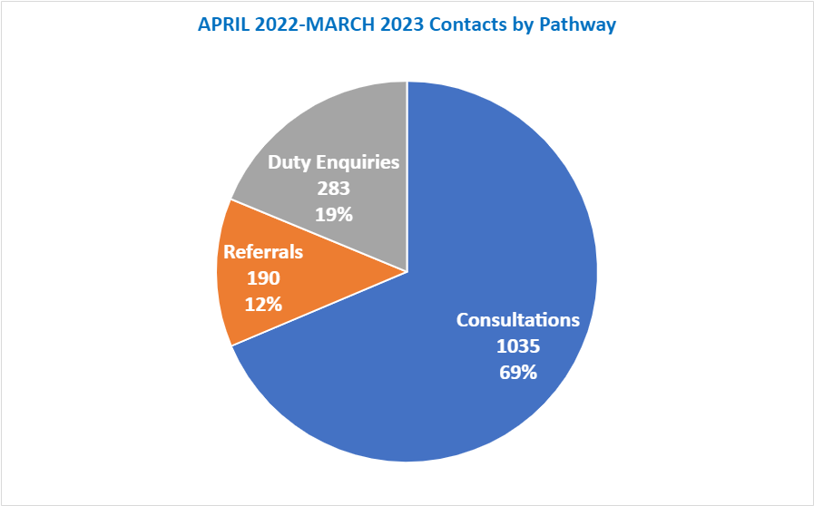

Category of Concern

The graph below shows the categories of concern reported to the LADO. The category ‘Not Applicable’ and ‘Regulatory Body’ relate to duty enquiries whereby the contact is not a reported concern but a request for information.

  - Contacts by Category of harm
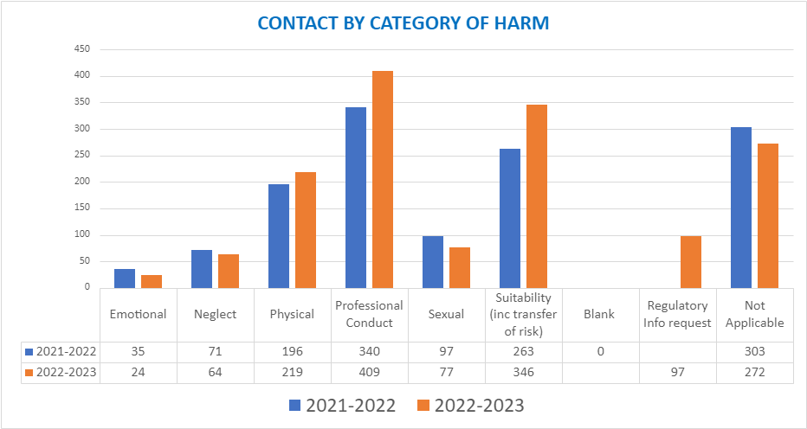

This chart comparing the allegation categories over the last two years indicates that the highest number of contacts to the LADO service remains those related to professional conduct and suitability. Most of the professional conduct cases will be at consultation level and many suitability cases has not been clearly identified.

Suitability and conduct issues do not always lead to a LADO ASV meeting but require significant input from LADO in ensuring that employers are meeting their responsibilities and managing concerns through the appropriate channels, which may include formal disciplinary procedures. The level of conduct and suitability issues referred to LADO during this period evidences the need for organisations to create a culture in which all concerns about adults (including those that do not meet the harm threshold) are shared and dealt with appropriately.

Of the ‘harm’ categories (emotional, neglect, physical and sexual) the physical harm category remains the highest number of referrals. This is consistent with LADO teams across the region and nationally. It also reflects those cases where restrictive physical intervention has been used and a child may have been injured as a result of this intervention.

The increase in suitability referrals this year is an indication of the impact of the training and briefings to children’s social care. Suitability cases include those where the behaviour of an adult to their own children raises questions around the suitability of that adult to work with children in a professional or voluntary capacity. These referrals often come from social care or early help staff who are engaged in supporting the family or carrying out assessments on the family.

  - Referral Pathway – Category of harm

Category of Harm | 2022-23  Total | % | Previous year | %
Physical | 72 | 38% | 75 | 34%
Sexual | 29 | 15% | 38 | 17%
Emotional | 8 | 4% | 17 | 8%
Neglect | 10 | 5% | 20 | 9%
Professional Conduct | 28 | 15% | 37 | 17%
Suitability | 41 | 22% | 23 | 10.5%
Risk by Association | 0 | 0 | 1 | 0.5%
Other | 0 | 0 | 9 | 4%
N/A | 2 | 1% | 0 | 0%
Total | 190 | 100% | 220 | 100%

When it comes to those cases that meet the referral criteria, the table above and graph below highlight the category of cases that LADO had oversight of.

During this year, the risk by association has been captured as ‘N/A’ on LCS. This categorisation is based on the risk posed by the “person of concern” and within these cases, the risk is not posed by the individual directly.

For next year, the LCS process has been adapted to make it clear which case are being managed as risk by association and transferable risk.

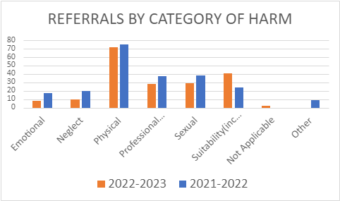

Referral Sectors

Contacts by sector in which the employee works/volunteers

In keeping with other Local Authorities, the greatest source of concerns are raised about staff within education. This is not surprising given that for 38 weeks of the year, every young person has around 30 hours of contact with adults in that sector. Outside of those young people in residential care or fostering this would be the greatest level of contact with adults who are not family.

Although 10 contacts about police officers is comparatively small, this is a greater level than other local authorities. A protocol is being developed with Thames Valley Police and the other local authorities that sit within the Thames Valley region, to raise awareness of the statutory reporting framework, outside of the police standards department, and to provide consistency within the reporting framework.

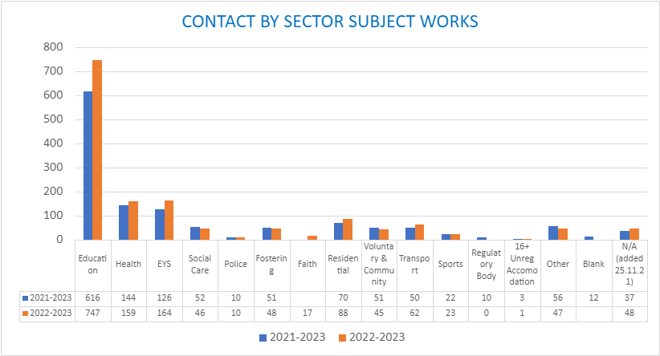
*Faith added 2022-2023 and was previously captured under Voluntary and Community

The following table highlights allegations of harm managed under the referral pathway by sector.

  - Referral Pathway – referrals by sector subject works

Sector | 2022-2023 | 2021-22
Education | 82 | 104
Early Years | 12 | 21
Fostering | 15 | 15
Social Care | 8 | 5
Health | 41 | 27
Voluntary & Community | 6 | 17
Transport | 7 | 13
Commissioned Services |  | 15
Residential | 10 | 3
Police | 1
Faith | 1
Sports | 7
Total | 190 | 220

Contacts by Referring Sector

As with contacts about education, the greatest number of contact comes from education. This again is consistent with other LADO areas and highlights that the training and guidance to schools is ensuring the allegation management process is being followed and self-reporting is taking place.

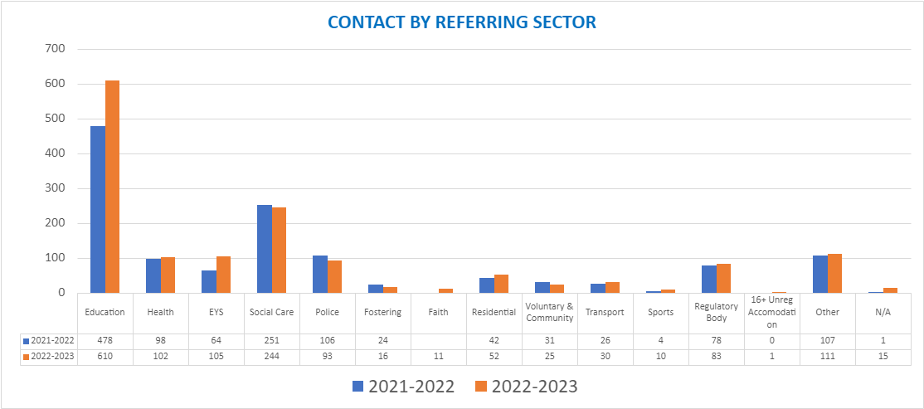

Outcomes

When an allegation is concluded the outcome is recorded. The definitions for outcomes are set out below.

- Substantiated: There is sufficient identifiable evidence to prove the allegation.
- False: There is sufficient evidence to disprove the allegation.
- Malicious: There is clear evidence to prove there has been a deliberate act to deceive and the allegation is entirely false.
- Unfounded: There is no evidence or proper basis which supports the allegation being made. It might also indicate that the person making the allegation misinterpreted the incident or was mistaken about what they saw. Alternatively, they may not have been aware of all the circumstances.
- Unsubstantiated: This is different from a false allegation. It means that there is insufficient evidence to prove or disprove.

To ensure fairness, it is important to ensure that outcomes are agreed for all allegations which are processed under the referral pathway.

Outcomes of allegations

(N.B. – the following table is based on data from LCS and working on the 187-referral total)

Outcome of Allegation | 2022-2023 | % | 2021-22  Total | %
Substantiated | 25 | 13% | 58 | 27%
Unsubstantiated | 33 | 18% | 46 | 21%
Unfounded or False | 20 | 11% | 26 | 12%
Malicious | 3 | 2% | 2 | 1%
Referral Threshold not Met | 0 | 0% | 3 | 1%
Not Applicable | 13 | 7% | 19 | 9%
Currently Active (no outcome yet) | 93 | 49% | 64 | 29%
Total | 187 |  | 218

The levels of outcome on LCS are lower than on the spreadsheet due to the closure processes and quality assurance checks on the case file. The LCS record is not closed off until all quality assurance actions have been completed, however the agreed outcome is recorded on the spreadsheet prior to these being completed.

Timescales for Conclusion

Timescales for completed Referrals

Timescale | Number of Cases  2022-2023 | % | Previous year  2021-2022 | %
Under 1 month | 33 | 17% | 63 | 29%
1 - 3 months | 59 | 31% | 51 | 23%
3 + months | 41 | 22% | 43 | 19%
Still Active | 57 | 30% | 63 | 29%
Total | 190 |  | 220

It needs to be noted that during this year, there was a period where the LADO cover was one FTE (Full Time Equivalent). During this period case closure timescales were impacted, and this would affect the on-going closure rate as caseload built. The recording highlights the closure of the formal process, and often the casework and investigation had been concluded in a far swifter time.

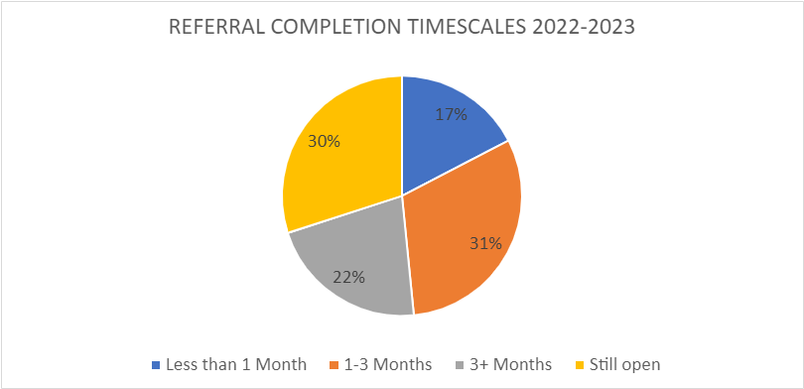

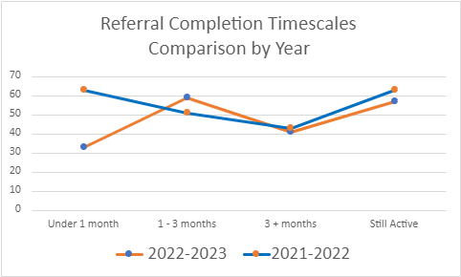

Overall Contacts Open/Closed

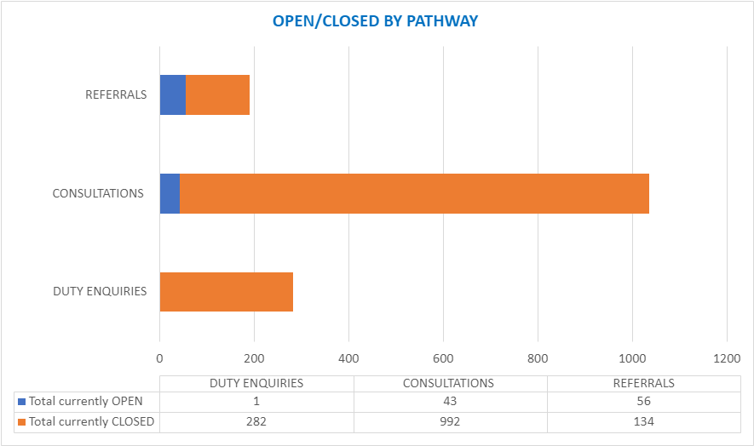

Impact and outcomes

Multi-agency involvement

  - Training

There continues to be an increased drive to raise the profile of the LADO amongst partner agencies. The LADO service has provided the following training/development sessions to the following in respect of Allegations Management:

- Team Meeting sessions for all social care teams: Taken up by Disabilities Team, FGC (Family Group Conferences) Team, Children in Care team, Leaving Care team. This is ongoing through regular liaison link meetings
- Introductory session for Academy recruits
- 6 x Early Years Designated Safeguarding Events
- 2 x Chairs of Governors and Headteachers
- Taplow Manor formerly Huntercombe Hospital
- Action for Children
- Health – Safeguarding Leads.
- 6x BSCP allegation management training sessions
- Children’s Services Briefing
Awareness is additionally being raised via the Safeguarding Partnership Board’s Website and school communications.

A conference is planned for autumn/winter 2023 with a focus on children living away from their family.

Feedback from the DSL training has been positive. Participants confirmed that following the training they “knew the roles and responsibilities of the LADO.”
The BSCP training evaluation indicated that the training was positively received by most of those attending. While two participants did have negative feedback, there was no comment, or context for the feedback and no contact information in which to follow this up. Those that did leave comments provided feedback such as

“It has given me a better understanding as to how the LADO works and the processes it works by.”
“I will know what to advise if allegations arise and I will have course materials to refer to.”
“It will support me in ensuring the safeguarding of children.”
“I am now more knowledgeable of the processes and confidant to contact LADO as and when appropriate.”
“I now have a better understanding of the LADO process and will put more details on any referrals I make.”

The LADO actively contributes to both regional and national LADO networks and has built a positive working relationship with neighbouring LADOs to ensure cross-boundary cases are effectively managed. Nationally the LADO handbook is being worked on with a draft being provided to the DfE for initial discussion. This is in preliminary stages and likely to be a few years in development as the implementation will need to reflect the diverse approach taken within the delivery of LADO requirements.

  - Case example:
The LADO team were contacted by an independent fostering agency with concerns about the care provided by two of their foster carers. The placing LA (Local Authority) also had concerns with these carers.
The concerns were around the approach the carers were taking to deal with bed wetting.
While the initial LADO response was to hold this at consultation level, challenge was received from the placing authority and the IFA. Due to this a meeting was called to hear all the information in order that threshold could be fully considered. Both carers worked within the children’s workforce in other LA areas and so a meeting was convened by the Buckinghamshire LADO inviting those areas along with the IFA and child’s social worker and team manager from a 4th LA area.

Information from the employers of the carers was brought by the other LADOs to the meeting and all three LADOs were able to consider the information presented and the risk that this potentially posed within the employment within each area.
The case concluded with all LADOs separately coming to the same agreement that threshold had not been reached and the IFA were able to follow their own complaints procedure without LADO oversight.

This is an example of a consultation case that required a greater level of work than a referral may.

It also highlighted the value of the LADO being unattached to those involved in the case so that the facts of the information could be considered without any response based on the knowledge of the child or the adults involved.

  - Case example:
One of our on-going cases, which has been open for almost four years, is in relation to an unregulated organisation, where the person of concern is also the owner and manager of the setting.

Multiple concerns have been received about the behaviour of this owner of a riding school since 2010, primarily around his conduct with young female riders during lessons and around the stables.

In the last referral in 2019 the reported abuse was historic, but supported the previous allegation accounts and was enough for the police to investigate.

The various LADOs who have held this case have explored all options to mitigate and manage risk within this case and the lack of requirement to affiliate with a national body meant that the only option to manage risk was with the licencing team in Buckinghamshire and the police bail conditions.

The LADOs’ oversight and ability to coordinate different processes to ensure that risk was managed, and on-going reviews being held to ensure that the risks were not lost in case drift has continued to the point where CPS (Crown Prosecution Service) are able to consider this case for charging.

This case highlights the importance of the LADO role. Without this external oversight licencing are unlikely to have been aware of the concerns about the provision. Although their focus is on animal welfare, this needs to consider the suitability of the licence holder to oversee the welfare of the animals. Without the LADO process and shared information, it is not clear if this would have been considered in the same way.

This case, whilst risk measures have been put in place, highlights the risks posed to children and young people in unregulated and unregistered provision. This is a known national issue and has been reported to the DfE by the National LADO group from its first conference in 2014. Whilst there are no answers, because this is not a simple solution, it demonstrates the flexibility and ingenuity that LADOs need to use.

Feedback

Learning/impact from allegations

  - Case Example:
An allegation was received that a baby, placed by an OLA, had suffered an unexplained injury to their ear whilst in the care of OLA foster carer who lives in Bucks.

Clear protocols were not applied, and Bucks LADO were not invited to the initial strategy meeting. The baby was removed from the care of the foster carer when the injury was found. A discussion took place between the OLA LADO and Buckinghamshire as to which LADO would have oversight. To ensure the BSCP procedures were followed, Buckinghamshire LADO took responsibility of the case in the absence of another protocol determining the responsible authority for the foster carer would lead as is the case in some local authorities.

There was a lot of disputes within this case in terms of professional understanding over the non-accidental principle in non-mobile children described in the consultant paediatrician's report and police challenging this description, the responsible LA for the foster carer undermining the allegation management process in terms of outcome following the investigation. There appeared to be professional optimism over the foster carers due to their experience and the fact no previous complaint had been made. This case evidences the importance of ensuring clear protocols are in place for dealing with allegations, importance of challenging due process and safeguarding assessments and where the responsible LADO needs to be able to evidence and defend their view on outcomes.

Case Example:

The LADO service have been concerned regarding safeguarding practices at tier 4 hospital within Buckinghamshire and this has been part of the auditing programme and findings escalated to the LSCP where consideration and agreement has been given to complete a local practice review.

Audit Activity

In the Ofsted full re-inspection published in February 2022, identified the following in terms of further learning.

“Allegations about professionals or volunteers who work with children are swiftly and appropriately responded to when they are first received by the local authority designated officer (LADO). Partly due to a large backlog of work, subsequent enquiries are not all closely tracked, and many take too long to complete.”

The above demonstrated the need to ensure a rigorous auditing programme was in place to support the service manager with oversight and an improved understanding of quality of work.
It was agreed that due to LADO information being sensitive and confidential any audit activity would need to be managed outside of the wider Quality Assurance framework, and an audit schedule was developed.

Overall findings across the variety of audits showed:

Areas of Strength:

- Good quality and consistent case recording
- Records reviewed evidenced a thorough and tenacious approach to establishing basic facts to inform decision-making.
- Good multi-agency engagement

Areas of Development:

- Evidencing the voice of child
- Ensure clear recording to evidence support to the person of concern
- Considering history of a person known to LADO particularly when linking low level concerns or suitability cases

A bi-annual audit report will be presented to SMT along with key findings for quarterly audits into the QSP quarterly report.

Other LADO Service Activity

We are the lead Authority in working with TVP (Thames Valley Police) to develop a local police protocol around managing allegations raised in respect of policing staff working in the children’s sector.

The LADO Service Manager attends the BSCP Education and Performance Subgroups.

LADOs attend the national LADO conference and regional meetings.

LADOs support Positive DBS certificates review for Bucks Council Client Transport

Conclusion

The LADO team continues to demonstrate progress against the improvement and action plan in respect of the service. The team work well together, collaboratively and are responsible for the developmental successes of the team by bringing ideas, experience, and evidence to shape practice and training.

It is positive that each recruitment process has been successful with a sizeable number of quality applicants. The team has a lot of experience within the children’s workforce that they use to shape the service and be creative in their approach to procedure.

The impact of the 4th criteria being added and addressing low level concerns has appropriately seen a significant increase in consultations to the service, however this has created capacity issues within the service and further resource is required to enable effective allegations management oversight and meet the requirements set out within Working Together 2018. A request has been made for additional funding to recruit an unqualified assistant LADO to support quantitative and business aspects of the role.

The LADO service is committed to continued improvement and will liaise with local and regional areas to standardise their work and processes. We will continue to raise awareness of the LADO role through the provision of training to the wider children’s workforce. Agencies must demonstrate a commitment to attend this training.

Appendices

Flow chart work with HR
Audit schedule

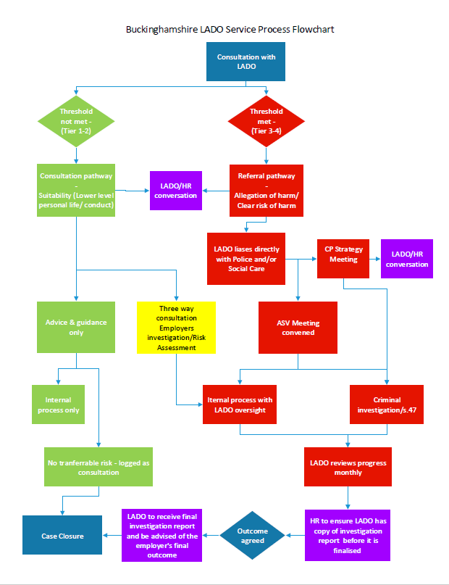
Month | Activity to be undertaken | Purpose | By Whom | Outcome – e.g. how many audits to be completed | By when | Progress | Next Steps
July | Review all LADO cases allocated to Lorrisa Webber | Worker is leaving, provides manager opportunity to ensure work allocated to new staff is clear and no gaps between someone leaving and someone else joining | LADO SM | 29 cases | 31/07/2022 | Completed | 4 cases to reallocate and the remainder will be closed
July / Aug | Audit selection of cases using audit tool – pilot | To pilot audit tool | AD / LADO SM | 5 cases | 31/08/2022 | Completed | To look at any themes and develop team plan once September deep dive audit is complete
Sept | Deep dive peer audit of LADO activity using bespoke tool developed as a team | Commence audit work | Team/AD | 12 audits | 30/09/2022 | Date tbc at development day 11/08/22  08/09/22 or  28/09/22 | Completed 28/09/2022
Sept | Peer audit per LADO | Look at developing consistency in practice across the team | Team | 5 per month | 01/10/2022 | Cases to be sent 01/09/22to be completed by 28/09/22 | Josie completed this with key headlines targeted HH provision to be able to consistently compare.
Oct/Nov | Case file audit of LADO activity using bespoke tool developed as a team | Commence audit work | Team | 12 Audits | 01/11/2022 | Audits to be allocated 03/10/22 and returned 31/10/22 | There has been a delay due to staffing changes. Cases allocated 01/11/22 and to be returned 30/11/22
Nov | Do themed audit for identified area from audits | Look at developing consistency in practice across the team | Team | 10 cases | 01/12/2022 | Audits to be allocated 01/11/22 and returned by 28/11/22 | Collaboration date set 01/12/22 moved from 16/11/22 due to AP sickness
Dec | No Audits completed.  Audit report to be completed. | Develop the themes for audit for 2023 | LADO Service Manager | 12 Case file and dip sample audits to be completed on alternate monthly basis. | 31/01/2023 | Completed | Quarterly audit findings to be included in the wider QSP audit activity.  Bi- annual audit report to be completed

