

**Child Protection Conference Service**

**Annual Report**

**2022/23**

# The Purpose of the Report is to provide an overview of the role and impact of the Child Protection Advisory Service in Buckinghamshire Council for the period

1 April 2022 to 31 March 2023

Report Authors:

Catherine Smith (Conference Service Manager currently Acting Head of Assessment Service)

Maryam Golding (Acting Conference Service Manager)

**Contents**

**Executive Summary.…………………………………………………………………………………….**3

**Recommendations……………………………………………………………………………………….**4

**Introduction and background…….……………………………………………………………….****.**.6

**One year on……………………………………………………………………………………………………****.**9

**Impact and outcomes………………………………………………………………………………….**19

**Executive Summary**

The purpose of this report is to provide an overview of the work of the Child Protection Advisory Service for the period 1 April 2022 to 31 March 2023.

Headline data includes:

* 549 children subject to Child Protection Plans as of 31st March 2023, a decrease of 27.7% from March 2022.
* 561 children were made subject to a Child Protection Plan in 2022/23.
* 777 children had their Child Protection Plan ended in 2022/23.
* Initial Child Protection Conferences were held in time for 485 children out of a total of 683 children. The average for 2022/23 was 71% ICPCs held in time.
* 18% of children the outcome of their ICPC was that a Child Protection Plan was not made.
* 1133 Child Protection Conferences were held in 2022/23 made up of Initial Child Protection Conferences (ICPC), Review Child Protection Conferences (RCPC) and Transfer In Conferences. This was a decrease of 28% from the previous year.
* 141 children started a Child Protection Plan for a subsequent time in 2022/23 which is 26.4%.
* Child Protection Advisor caseloads fell in 2022/23 to an average of 93 in March 2023, a decrease of 13%.

During 2022/23 there was a significant decrease in the number of children subject to Child Protection Plans. This was in part due to the increase in CP plans linked to the ending of each lockdown which had been worked through. The CPA Conference Service was able to support better threshold making through CPA consultations. CPA consultations were introduced in 2020 and are now fully embedded in practice. This meant that when there was increased activity into Children Services from MASH, there was not a further increase in Child Protection Plans. The timeliness of ICPCs which is a key indicator saw the improvements from 2021/22 sustained for the majority of 2022, however a decline in November was seen with a further period of improvement again. There is renewed oversight and scrutiny by the Conference Manager to support sustained improvement in timeliness but also to ensure oversight of safety planning for children subject to out of time ICPCs.

A significant development that took place in 2022/23 was a return to the office, and face to face conferencing as conferences shifted from being fully virtual to hybrid. The hybrid model that has been adopted is for the family, CPA, allocated social worker and note taker to attend the office and other professionals to join via a TEAMS meeting. Each conference room has technology that allows the family to see the professionals that have joined and the professionals to see the family. This ensures that the visual advantages of the whiteboard in the model are again in operation.

The key roles and responsibilities of Child Protection Advisors (CPAs) in terms of management of Child Protection Conferences and their roles and responsibilities is outlined in Working Together 2018. Buckinghamshire Safeguarding Partnership publish the procedures that cover Child Protection Conferences, and this can be accessed by partners and families.

The link for these details can be found at:

[Buckinghamshire Safeguarding Children Board Procedures Manual](https://bscb.procedures.org.uk/page/contents)

Alongside the chairing of conferences, the key roles of CPAs are:

* Ensuring that the outline Child Protection/Child in Need plan is focused on realistic and achievable outcomes for children. CPA help ensure that Child Protection Plans include partner agencies and address the parental harm and the individual needs of each child in the family.
* Offering a consultation ahead of all requests for ICPCs. This is to support threshold decision making (this rests with the team), improve safety planning for families and ensure that assessments will gather the right information.
* Completing midway reviews for all children. The purpose of the review is to ensure the plan is making progress and to ensure that practice standards for visits and core groups are being maintained.
* Ensure that they address drift and delay for children – CPAs use the development of strong relationships with teams to ensure where possible and appropriate that issues are resolved with the social worker or manager.

Other key tasks the Conference Service has undertaken includes:

* Offering development sessions to the Academy Social Workers
* Developed and implemented a clear process for ICPC requests to made which is now embedded and has supported improvements.
* Development of dip sampling tool to ensure that CPA footprint and impact of work is evidenced on Children’s files. This also supports achieving consistency in service delivery
* Improved working relationships with key partner agencies
* Development of conference rooms in the new Wycombe offices.

**Recommendations**

* Continue to develop and support an alternative way of supporting and developing plans for children where the primary issue is risk outside of the home. A session has taken place with Carlene Firmin, University of Bedfordshire across the council and we now want to move to developing a style of meeting and planning that recognises the significant harm that children can be experiencing but acknowledges that this harm is not attributable to the parenting that they are receiving.
* Continued development of Child Protection Plans so that they are child friendly and succinct. The outcomes of the plan should describe how the child’s life will improve when the plan can safely end and an emphasis on how the network around a child will support them if they are exposed to further harm. The focus is to improve outcomes focussed planning for children.
* Engage with partners to ensure that plans are reflective of the multiple needs faced by the families and the wider role partner agencies play in supporting children to be safe from ongoing harm.
* Review of the feedback form as families return to face-to-face conferences. This will create better opportunities to gain insightful feedback from families and improve their experiences.
* To identify themes from dip sampling and through regular learning and “testing” of the learning this will ensure outcomes for children and practice is improved.
* Reintroduction of a process which reviews all CP plans over 12-month Conference Manager, relevant Team Manager in frontline team and CPA.

What will be the impact:

* Improved or alternative plans for children experiencing extra familiar harm so the context of the harm is addressed as well as the individual experience of the child. Families feel less blamed and are seen as safeguarding partners in plans for their children.
* CP plans are consistently written in family friendly and accessible language and can be used as a tool with the family to support change. The plans will be more accessible to children and be used as part of the direct work with children. Plans will ensure that where possible and appropriate family and friends will, step in to protect children from further significant harm if the changes made are not sustained.
* The ongoing development of the CPA Conference Service both in terms of hybrid conferences and development of Child Protections plans will be linked to feedback from families who have experienced the Child Protection process in Buckinghamshire.
* Reduction in the number of children being subject to longer plans that ensures that drift and delay is addressed but equally plans are ended in a timely way when parental harm has been addressed.
* All professionals will contribute to a better understanding of a child’s lived experiences and as a result better threshold decision making and planning and outcomes for a child and their family.

**Introduction and background**

**Role and function of the CPA service**

The core business of the CPA Conference Service is to chair Initial and Review Child Protection Conferences in line with the Strengthening Families approach and in accordance with relevant legislation, statutory guidance and the local safeguarding partnership’s Child Protection Procedures and agreed Practice Standards.

The Conference Service Manager and the Child Protection Advisors (CPAs) are also involved in quality assurance activities, training, case mapping and consultations with social work teams and multi-agency partners.

The team plays a key role in the improvement of practice and safety planning for children subject to child protection plans. It also provides challenge to drift and delay and ensures that the views of the children, parents and carers are given sufficient weight in considering the issues of significant harm and developing suitable plans to address them.

Overall, the CPA act as a ‘critical friend’ for staff and partners, bringing challenge and support to raise the standard of child protection practice for vulnerable children and young people who have suffered, or are at risk of suffering significant harm of abuse and/or neglect.

They promote and share best practice and learning as an integral part of the local quality assurance framework and seek to work collaboratively with social work teams and other relevant services to achieve change, promote safety planning and achieve good outcomes for vulnerable children and young people in need of protection.

**Professional profile of the service**

All CPAS are qualified social workers with many years of post-qualifying experience in children’s social work and have held various management roles. As of March 2023, 3 of the advisors had been in post for more than 12 months and a previous CPA rejoined the team. Advisors are provided with monthly 1:1 supervision by the Service Manager, and they also participate in Coaching for Performance. The Service Manager provides management oversight and support, alongside monthly performance monitoring and service development.

Since April 2022 there has been changes in both the management cover and CPA staffing in the Conference Service. In September 2023, the Conference Manger moved to Acting Up as Assessment Head of Service and Maryam Golding, an experienced Child Protection Advisor stepped up as Acting Conference Service Manager. These arrangements are now confirmed until the wider Childrens Services initial transformation is completed.

**Development of a hybrid model of conferencing**

Following the first lockdown in March 2020, all conferences moved to a virtual meeting. In 2022 with the return to the office the service needed to consider how a a return to face to face conferencing would be established.

The Conference Manager attends the London Child Protection Manager’s Network which includes managers from across London and the Southeast. From discussion at this forum, it was clear that there had been a push towards Hybrid conferencing which has been evidenced to be working well for families across London and the Southeast. Differing Local Authorities have taken different routes depending on resource implications but many of the challenges in moving back to face-to-face conferencing are shared. These include some challenges from staff and families and the lack of IT equipment.

The positive benefits for families, particularly those with learning difficulties, younger parents, and more vulnerable families, such as those families where English is a second language, suggested that the Hybrid Model should be launched.

The initial pilot was delivered by the team in September to November 2022, which gave a learning opportunity in terms of challenges around moving back into the office and using the board effectively as well as staff members readjusting. This took place in Aylesbury and Amersham initially due to lack of IT in the Wycombe office. Differing technology was available in these offices which helped to understand the requirements for effective service delivery.

From January 23 to March 2023 increasing number of hybrids were held, however an informed decision was made to allow CPAs and Social Workers to get ready for the implementation of all conferences moving to being hybrid from 3 April 2023 in a phased manner. During the phased return it gave the service an opportunity to focus on the most vulnerable families and respond to the increased requests by families for face-to-face meetings.

The move to face-to-face meetings needed significant buy in from frontline teams as initially there was a lack of understanding re: the importance of returning to face to face conferences. The locality CPA/ATM/TM meetings were successful in conveying the hybrid working model, with many of the ATMS having come from Local Authorities where this type of working had already been well established. Turnover in staff has been sighted by some managers as to why social workers have not always known about the new way of working. CPAs are now familiar to being back in the conference room environment and are reporting that, in terms of family's participation and understanding, the whiteboard offers a more inclusive and effective way of showing them clearly where their strengths and grey areas lie. It has been noted that the families were professionals find most challenging in terms of engagement are most likely to ask for a virtual meeting. However, it is recognized that these families would benefit most from face-to-face meetings.

The developmental afternoons after team meetings enable the service to discuss issues raised by CPAs in relation to Hybrid conferencing. Topics include health and safety at conferences, split conferences, which were managed differently over the virtual conference, and the use of the whiteboard which varies with each CPA.

During the initial trial and implementation phase, a number of CPAs who lived a distance from Buckinghamshire took the decision that they were unable to commit to attending the office up to 4 days a week. This has meant that both locum and permanent CPAs have needed to be recruited. In line with the national picture, recruitment is challenging, the service has been successful in appointing a further permanent CPA and are confident that all permanent posts will be filled during 2023. All new appointments are aware of the commitment needed in terms of attendance at the office.

**Strengthening Families Framework (SFF)**

The CPAs are routinely using the Strengthening Families Framework (SFF) to support discussion and consultations with social work teams and case mapping with multi-agency partners and families. The SFF model and the use of solution focused questions has enabled CPAs to be more focused on the child’s lived experience and therefore enable discussions which consider the significant harm, what it may look like in a child’s daily routine and facilitate opportunities for families to consider what change needs to be made to reduce this harm.

The Strengthening Families Framework is used in conferences and in other parts of Children’s Services. This is a model that focuses on what are the family’s strengths, which can be built on to address the worries/risks that exist in the family. The family are invited to take ownership of creating change to enable their child to live safer lives and for that change to be sustainable. The team draw on several strength-based approaches in their work with families in conferences. All CPAs will prepare for conferences by reading the child’s record, completing mapping for children and case discussion with the social worker as appropriate.

In 2022-2023 regular peer development time has been reintroduced within team meetings. At present the service is focused on achieving consistency within conferences, focusing on the use of language used and how CP plans are written, with particular focus on increased participation of families and partners.

In addition, where possible no conferences are held on a Friday. This is in part due to the impact on families having to attend a meeting that can cause challenges which cannot easily be supported by professionals the following day and to ensure that CPAs have a pause at the end of the week to ensure plans and notes have been completed and for their supervisions to be completed.

There is improved consistency in delivery of conferences due to an agreed agenda, agreed standards in relation to case recordings, use of the Resolution From and recording of CPA consultations. The team have agreed headings for case recordings which focuses on the child’s voice/lived experience, impact of the plan and recommendations. The average caseloads across the service can mean that at times caseloads are high but it is positive to note that child focused conferences and child safety has been relentless in the management of casework by the CPAs.

Child Protection Plans are developed by focusing on the evidence required to demonstrate change in a child’s life and how the family and the professional network will know when the outcomes have been achieved. The review conference focuses on evidence that outcomes have been achieved rather than actions have been completed. Feedback from Ofsted published in February 2022 indicates that good quality plans are being produced but with improvements that can still be made in those plans. The CPA Conference Service is developing a presentation to help social workers have a better understanding of how to present at conferences, so they can concisely pull out the impact on the child and the child’s voice. It is hoped this will support in plans that reflect the child’s voice and use less professional language.

**ONE YEAR ON**

**Child Protection Conferences**

Number of children subject to Child Protection Plans

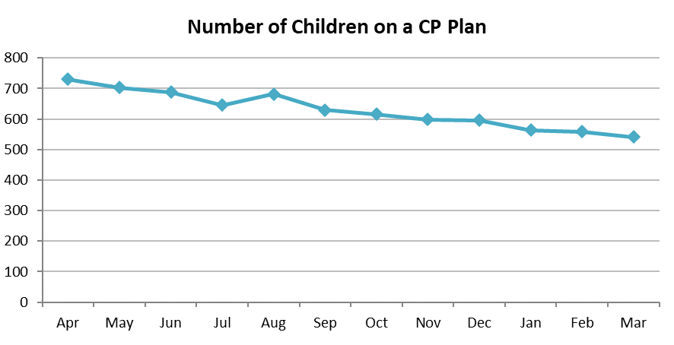

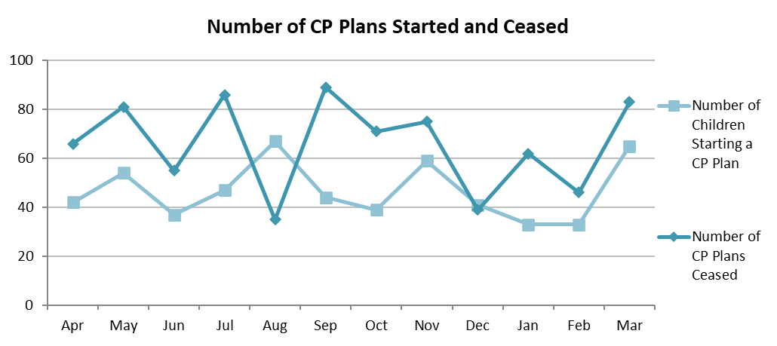

In 2022/23 there was a significant decrease in the number of children subject to Child Protection Plans from 759 children at the end of March 2022 to 549 children at the end of March 2023. From the data it is clear that for all months with the exception of August and December, a higher volume of plans had ended then started. In total 561 children started a plan across the year whilst 777 children had their plan ended.

The reasons for this will be multi-faceted but the service is aware that following the end of each lockdown the Conferencing Service saw a surge in referrals, and this led to a subsequent rise in Child Protection number. In addition, interventions to support families were reduced during the pandemic. There has been an overall reduction in plans coming into the system, but equally the number of children both coming to ICPC, and the number of plans being made has also reduced.

There has been ongoing work to ensure that the right children come to ICPC, and there is evidence that the impact of the CPA consultations as well as CPAs ensuring thresholds are met in ICPCs, is beginning to ensure application of threshold is more consistently applied. There is still work to be completed as 683 children had an ICPC held to consider if the threshold was met for ongoing significant harm and 561 children met that threshold. This means 18% children did not and it is important to ensure that where possible families are not being taken to conference where threshold is not met. The Conference Service Manager is supporting application of threshold at MASH meetings and early indications are this is supporting better and consistent decision making in relation to strategy discussions which in turn will support better threshold decision making from s47 enquiries.

The CPA Conference Service continues to engage with the teams to work with families prior to bringing it to conference, thus ensuring that Child and Family assessments are considered and analytical in terms of being able to show the impact on the children’s lived experience and their capacity to thrive and achieve. In addition, for older children or where there are concerns of extra familial harm or self-harm, consideration is given to what parental harm the Child Protection Plan would be addressing. If there is no parental harm, but the child is still experiencing or at risk of experiencing ongoing harm, consideration is given to other plans to support the child or young person.

There is work planned to look at CP planning for children who experience Risk Outside of the Home (ROTH), and consideration is being given to alternative planning. Initial work has been undertaken with the Exploitation Hub to progress a ROTH category.

Number of Child Protection Conference and Timeliness

In 2022/23 the overall number of Conferences held across the year fell from 1584 meetings to 1133 meetings – a decrease by 29% and an overall fall of children subject to Child Protection Plans by 28%. As can be seen by the data the number of conferences dipped in December but did not return to previous levels until March.

Timeliness for both ICPCs and Review Conferences were lower at the end of March 2023 than March 2022, but timeliness can change each month. The system of weekly reporting of ICPCs has been reintroduced to identify themes and solutions, and complete targeted work where needed with teams. The main themes and solutions are as follows:

* ICPC request is made late
* Child and Family Assessment is not ready
* Family asks for another date – this will be considered but will depend on the reasons given and the level of risk involved for the children
* If an ICPC is held out of timescales there is a review of the safety planning for that child/ren to ensure that they do not experience any avoidable harm – Ofsted published in February 2022, noted that this approach had been successful in ensuring that no child/ren experienced any avoidable harm and most children had robust safety plans in place. All CPAs review the Safety Plan as part of their consultations and support improvements if needed. These are further reviewed by the Conference Manager and any gaps are escalated to the relevant manager

In addition to the above the CPA conference service has used the CPA consultations to also ensure that they can follow up on any consultation that does not result in the expected ICPC request. To assist with the booking of CPA consultations an inbox has been introduced and the CPAs have a rota for when they cover the inbox.

The themes for timeliness of review conferences are late sharing of Child and Family Assessments, assessment not being written, extensions being requested due to change of social workers and conferences being inquorate. Each theme has been addressed and CPAs will use the Resolution Form as way of noting these issues due to the impact on children in delayed review of their plans. We know that this area is impacted by the staffing challenges within the Health and Protection Teams and the change over of staff.

**Children on Plans for more than 2 years**

During 2022/23, collaborative work was undertaken with the Help And Protection (HAP) teams to review children on plans of 12 months plus to look at what the reasons were and how plans could be progressed, either through escalation to Public Law Outline via a Legal Planning Meeting or a step down to Child In Need at the next review meeting. This collaboration was successful in ending some longstanding plans and supported in making the distinction about parental harm and significant harm. The impact can be seen in the data with a drop until November and then an increase that has been sustained. The collaboration was halted when the previous Conference Manager moved to her new role and will again be put in place by the current Conference Manager.

**Number of Children who experience more that one period of Child Protection Planning**

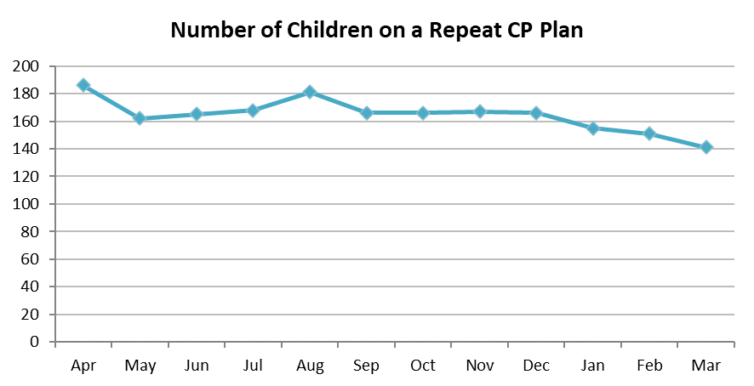

The overall number of children on a repeat plan fell in 2022/23 in 2021/22 169 children started a subsequent Child Protection Plan as opposed to 149 children in 2022/23. However, as the number of overall children subject to plans fell there was an overall percentage increase from 23% to 26.4%.

Buckinghamshire is a large county and the 3 areas that are covered can have different demographics but across the county many children live in families with persistent themes of parental mental health, alcohol and drug misuse and relapse after a period of safer or no use and periods of adult relationships being safe and healthy. For older children early harm and trauma can lead to risk of extra familial harm whether in terms of self-harming or exploitation. CPAs ensure that outcomes for children are being achieved and ensure that evidence provided is triangulated and that this is not just self-reported by families.

An area of development that is due to be proposed to ensure that there is a different response to the key reasons why children may experience repeat Child Protection Planning.

* CPAs will undertake a peer review of children who are subject to repeat plans with a view of developing plans that ensure where possible if a vulnerability reoccurs the outcome for the children is that they are not exposed to ongoing harm. For example, poor management of mental health may lead to drug misuse which contributes to unsafe adult relationships. CP planning would end when the mental health is now managed, and the risk factors have been addressed. If there is a further deterioration in parental mental health, the contingency plan is acted upon and the children are not exposed, for example extended family care for the children this time.
* Greater use of Family Group Conferences to provide sustainable contingency planning by family and friends to step in to avoid further exposure to harm.

**CPA Caseloads**

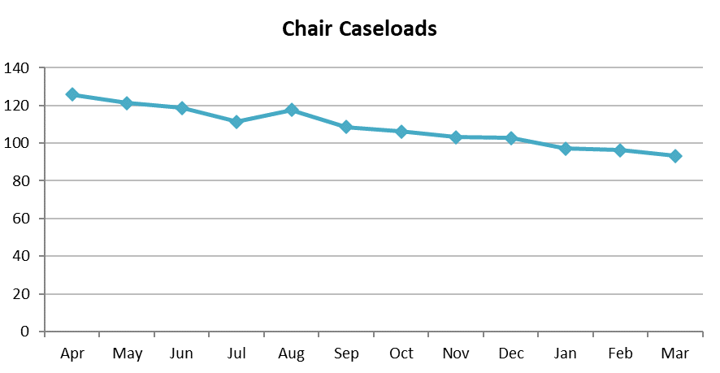

Average CPA caseloads decreased in 2022/23 in line with decreasing number of children subject to Child Protection plans and the decrease in overall number of Conferences held. At the end of March 2023, average caseload was 91 children – just above 85 which is the agreed level. Despite number of children continuing to fall there has been an increase in caseloads due to a decrease in staffing. This has meant that the Conference Manager has had to cover conferences to support children having their meetings held in a timely way for them.

These figures do not describe the impact of changes in the CPA Conference Service and challenges in finding replacements for either permanent members of staff or locum CPAs. The impact for children and their families meeting more than one CPA and the impact this has on the oversight between conferences when there is a changeover. Dip sampling has highlighted that midway reviews are not taking place as consistently. Currently the average caseload is higher due to vacant posts but once recruited to, this will the CPA Conference Service ensure consistency across agreed stand

**Profile of children on a child protection plan**

Categories

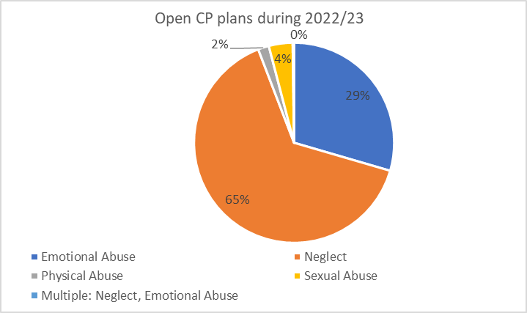

Gender

Ethnicity

Age

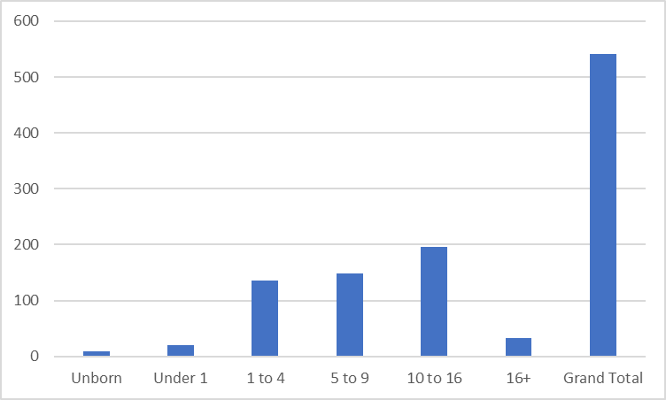

The most prevalent categories used for Child Protection Plans are Neglect (65%) and Emotional Abuse (29%). In line with other years, they cover the majority of children although in 2022/23 more children were on a CP Plan under Neglect (increase of 6%) than Emotional Abuse (decrease of 4%). Sexual abuse remained the same and a slight decrease for Physical Abuse. 2 children had a dual category which is not usually used in Buckinghamshire and may be a result of children transferring from another Local Authority. Where there are concerns that span emotional and physical safety concerns then Neglect will be used.

The split in gender for plans has remained fairly static from 2021/22 to 2022/23 with similar levels of plans for girls and boys. The percentage of plans for unborn babies remained the same at 1%. I child was recorded as indeterminate. We have children who come to conference who may not identify with the gender given to them at birth and there is a need for our electronic records to accurately reflect how older children and their parents may wish for their gender to be recorded.

Although the number of plans across all children fell in 2022/23 the spread across the age groups remained relatively static.

With regards to the ethnic background of children the most notable statistic is that for 12% of children their ethnicity has not been recorded. All CPAs will ensure that CP Plans reflect the unique attributes of each child and their family, but an area of development is to ensure that this is correctly recorded on the child’s electronic record. For those children where their ethnicity is recorded it follows the breakdown of the previous year.

**Child Participation**

It is important that young people aged 10 or over are offered the support of an advocate and have the opportunity to attend their ICPC if appropriate. Since April 2018, there has been an advocacy service which supports young people aged 10 and over to participate in their conference. The advocate is part of the Family Group Conference Service which comprises of self-employed advocates. The referral process has been adjusted in 2023 following the outcome of a review by the Ombudsman. A referral to the advocate with details of the family is now only made once the parents have confirmed that they agree with their details being passed on. Given the tight timescales this initially meant a number of children missed out, but social workers are reminded about seeking consent at an early stage and a leaflet has been developed in consultation between a CPA and FGC lead coordinator which will be launched in 2023.

The advocate meets with the young person before the meeting to talk about how they would like to participate and obtain their wishes and feelings. The advocate then attends the meeting to either support the young person or attend on their behalf. The feedback from the CPAs is that advocates help children provide their wishes and feelings in a powerful way in conferences and the advocates are skilled in supporting children. At conferences when the advocate reads out what their child has said that is has a profound impact on parents which can often support them to make the changes needed to ensure positive outcomes for them and their children. Some children attend without the support of advocates and are supported by the CPA to contribute in the most meaningful way.

In 2022/23 there were 210 referrals for an advocate for children 10+ and advocates attended 144 ICPCs – this was a decrease from 233 in 2021/22. A leaflet has been developed which will be launched to help families understand the purpose and role for the advocate.

The Strengthening Families Framework for conferences makes explicit reference to the voice of the child and it is one of the main domains. All CPAs are looking for evidence of the lived experience of the child and their own voice about what is working well in their families and what worries they have. They will ask all participants at conference to share what they know of the child’s voice and for younger children what their observations are. The CPAs have identified that this continues to be an area where improvements can be made. There is a specific section in the notes and on the agenda to ensure the child’s voice is clearly captured. An area of development is to make CP Plans more accessible to children.

There will be more development work done around participation of young people/children within conferences, especially as there is more work being done with having conferences for children at risk outside the home.

Their attendance will be crucial to planning for them and it is hoped that this will also feed into more children being involved in conferences, either directly or through direct work sheets that will be devised to support social workers in talking to children about their plans and how it feels to be living in their homes, what they feel and how they see their plans. This could involve interactive worksheets on different mediums like the Social worker’s mobile phone or laptop.

**Practice Development and Practice Improvement**

A critical element of the Child Protection Advisor role is monitoring individual children’s plans to identify and challenge issues of drift, delay or poor practice.

This includes a range of informal activities as well as the formal Escalation and Resolution Process which is the process where the CPA can raise concerns that have not been resolved through the informal stages. During 2022/23, the use of the Resolution Form was down, this did not reflect less oversight by CPAs but did reflect the desire by CPAs to build strong relationships with teams. This is an area where with new CPA’s joining the team, we anticipate some challenges to consistent application, and thus are working with the team to ensure this area of work is focussed in on.

The use of the formal Resolution Form in 2022/23 was reduced from a total of 323 Resolution Forms in 2021/22 to 216 Resolution Forms. The form is used to identify when Practice Standards are not being met for children, such as statutory visits, core groups not being held or Child and Family Assessments either not completed or shared with families before Initial or Review Child Conferences. It is also used to address drift and delay for children. Alongside the Resolution Form, CPAs will use informal routes to try and avoid the need for escalation.

The data indicates that the most common reasons that Resolution Forms being completed were:

* C&F assessment not completed in timescales before Child Protection Conferences
* C&F assessment not being shared with family in timescales before Child Protection Conferences
* Visits or core groups are either not recorded as having taken place or have not taken place within statutory timescales.

The next most common reasons indicate that the quality of the work being undertaken, and the impact of drift and delay is being addressed:

* Decisions and Actions not being carried out
* Missing/incomplete or poor standard documentation

The CPAs have continued to work hard to use relationship-based nature of strengthening families with the social work teams and used existing mechanisms to indicate when they felt there were practice issues or drift and delay as well as the use of the feedback form. These escalations have also included challenge to partner agencies. An area of development being explored is regular meetings between the PLO Manager and Conference Manager to review thresholds for families where there are concerns about drift by the CPA linked to lack of LPM or drift in PLO.

In addition to the “critical friend” role there has also been a focus on contributing to safeguarding training to address themes that have been highlighted by CPAs either through specific training for individual teams or partner agencies.

The CPAs role in delivering training as part of the Safeguarding Partnership training has been re-established and there are CPAs in the team that have a particular interest in delivering training. The Conferencing Manager and CPAs remain willing to offer any training when requested and provide opportunities for social workers to observe conferences (with parental consent) where appropriate. In 2022/23 they contributed to the Safeguarding Board training, offered sessions to the Assessed and Supported Year in Employment (AYSEs) in the Academy. They also provided a skill share with Aylesbury Help and Protection team.

In addition, stronger relationships have been developed by the Conference Manager with Health Visiting managers and One Recovery Bucks which has supported improved attendance at conferences from these agencies and given the success we look to strengthen with other partner agencies in 2023/24.

**Impact and Outcomes**

In 2022/23 the following Recommendations were made, and progress has been made against each action.

* *The number of children subject to Child Protection plans is historically high in Buckinghamshire. The number of Child Protections plans should reflect the number of children experiencing significant harm or likely to experience ongoing harm. There is a planned review to better understand what has driven the significant increase. Lines of enquiry will include alternative pathways where the harm is not attributable to parents, increased use of early help, initial safety planning and increased use of Child and Family Assessments before deciding if ICPC is recommended.*

The impact of the developments in 2022/23 have meant that the proposed impact of confidence that the right children are subject to Child Protection Plans and alternative pathways for children are always considered as part of the assessment process is being implemented and achieved. There has been a reduction in Child Protection numbers ensuring that those children subject to plan and their families had an opportunity to have the least intervention that is appropriate but equally other children are escalated at an earlier stage.

In addition, CPA consultations are now part of embedded practice and the reduction in the number of CP Plans and the sustaining of lower plans despite increased activity by MASH and Assessment teams can be linked to increased confidence in maintaining thresholds.

* *Review of the Resolution process and escalation so the focus is on the impact on children and increased consistency across the CPAs. This will address the feedback from Ofsted which outlined that whilst there is oversight from the CPAs between conferences, the scrutiny is not as effective as it could be when plans are foundering.*

There was increased compliance with the use of Resolution Form and those CPAs who found completing the form a challenge were given additional support. However, as the team experienced a period of instability, the use of Resolution Forms has dipped. The proposed impact of improved consistency within the Conference Service of the use of the Resolution Form is not fully achieved but themes are gathered through team meetings then acted upon. For example, CPAs noted lack of attendance by ORB workers and given the number of families where drug and alcohol contribute to parental harm this was identified as a gap. The Conference Manager used her existing relationship to further explore and understand the challenges for ORB. Running alongside all of this is the continued development of relationship based work with social work teams that reflects the values of working within a strengths based model – this implemented at all levels and in all meetings. This ensures that escalations are focused on the lived experience of the child and that challenge is accepted as healthy both from a CPA but also to a CPA.

* *Increased feedback from parents and children and demonstratable impact of the feedback received.*

As we have moved towards fully embedded face to face conferencing this will allow for better engagement with families about the impact. We are looking to develop a direct work tool to support gathering children views about the impact of their plan. Conferencing Service continues to have monthly feedback weeks when the feedback form is promoted. There is still scope for better engagement from parents and children who attend conferences. Feedback is reviewed to ensure that where we can we respond. An example is that there was feedback from parents and professionals during virtual conferences that they would have been more productive in person and as explained in this report this has now been actioned. Feedback is generally positive about how CPAs run conferences, but it was noted that introductions can vary and not include all necessary information. The Conference Manager is in the process of developing an agreed introduction that will sit alongside the agenda.

* *Focus on providing alternatives pathways for children who are experiencing significant harm due to exploitation outside of the home.*

A CPA now sits regularly on MACE which has supported a better understanding of how exploitation concerns are supported. There is development work planned for 2023/24 that will ensure improved plans for children experiencing risk outside the home, so the context of the harm is addressed as well as the individual experience of the child. Families will feel less blamed and seen as safeguarding partners in plans for their children.

* *Development of hybrid conferencing model*

Face to face conferencing using a hybrid model is now in place. The move to hybrid Conferencing has ensured that key elements of the Strengthening Families model is again being untilised – this is both in the importance of relationships building to support change and the use of the whiteboards to describe to parents/adults in the family the impact on children on both the strengths but also the worries which can be a powerful tool to support change. It also supports the child’s voice being more present in conferences as well. The impact for the family is that they received a more personal experience in the conference. Family members can be focused on the meeting and the CPA is able to use their relationship skills more fully. Some families have noted that they would like all professionals in the room and currently this can be facilitated as requested.

* *Review of children subject to repeat CP plans which a focus on those coming back on within 2 years.*

The CPA always consider previous history and the impact for safe decision making and give recommendations for LPM where necessary. However, whilst there has not been an increase in the number of children, we have not been able to significantly reduce the number and will continuing to address underlying reasons in the CPA peer development work in 2023/24.

* *Agreed standards within the Conference Service to build on the headings used in case recordings so CPA footprint is purposeful for the child and supports achieving outcomes for children.*

During 2022/23, there was positive feedback received about the quality of CPA footprint through dip sampling. Team Managers use the CPA Consultation case note to help them review threshold and safety planning. The challenge is to remain consistent in its application during a period of staff shortages which current dip sampling is evidencing. Dip sampling is now regularly undertaken and this has shown that whilst over 50% meet good there is more to do to ensure improvement in consistency and the CPAs are working towards improved compliance but they continue to ensure that safety planning and effective plans remain a key focus of their work.

* *Strengthened relationship with the Safeguarding Children Partnership Board to ensure that partner agencies are fully engaged and contributing to improved outcomes for children.*

CPAs and Conference Manager have been involved in both delivering the Safeguarding Training and running mock conferences as well as providing input to the Academy and bespoke training for teams. This ensures that all professional participants understand their role, how to contribute both verbally and in report writing and understand their own responsibility in determining if a child is subject to ongoing significant harm.

Improved attendance at conferences from One Recovery Bucks (ORB) and good communication following Conference Manger running a pilot where all CP plans which noted referral to ORB this was sent to Head of Safeguarding at ORB. This ensured that the ORB worker would be attending the core groups. This has proved successful and will not be embedded in ongoing practice. Consideration will be given how this can be rolled out to other key partners when patterns of poor attendance are noted.