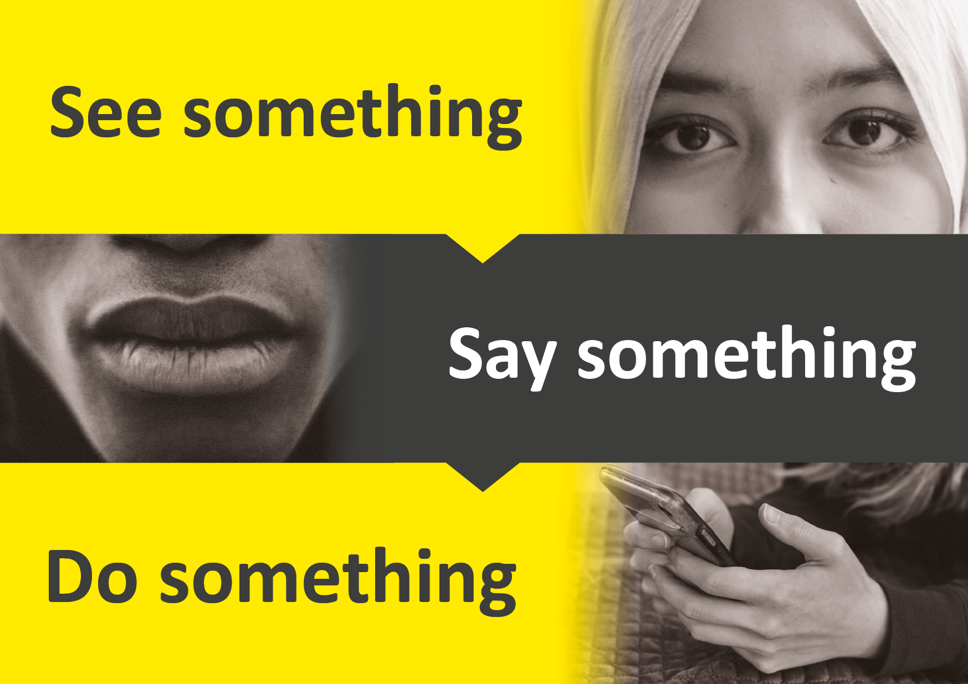
A Professional’s Guide to
Making a Safeguarding Concern

What is a safeguarding concern?

A safeguarding concern is where an adult who has needs for care and support (regardless of whether those needs are being met) may be experiencing, or is at risk of, abuse or neglect. As a result of their care and support needs, they are unable to protect themselves from either the risk of, or the experience of, abuse or neglect.

What does safeguarding do?

Safeguarding means protecting an adult’s right to live in safety, free from abuse and neglect. It is about people and organisations working together to prevent and stop both the risks and experience of abuse or neglect, while at the same time making sure that the adult’s wellbeing is promoted including, where appropriate, having regard to their views, wishes, feelings and beliefs in deciding on any action. This must recognise that adults sometimes have complex interpersonal relationships and may be ambivalent, unclear or unrealistic about their personal circumstances. (Care Act, 14.7, 2014)

Is an adult able to protect him / herself from abuse?

If an adult with care and support needs is experiencing, or is at risk of, abuse or neglect and is unable to protect him / herself from the abuse because of those needs, staff working with the adult have a duty to raise a safeguarding concern to share this information with the local authority.

If possible, a member of staff should have a conversation with the adult at risk as soon as possible to discuss whether they think that they are able to protect themselves from abuse. If it is not possible to have a conversation safely with the adult straight away then a safeguarding concern should be reported immediately if the adult is at risk of, or experiencing, abuse or neglect.

A crucial factor to remember is that many adults with care and support needs may be able to protect themselves sufficiently from abuse, neglect or exploitation by others. We must remember that an adult is not inevitably unable to protect him / herself from abuse or neglect just because of their age, frailty or disability. For example, an adult with a disability who has mental capacity to make decisions about their own safety could be perfectly able to make informed choices and protect themselves from harm.

Some circumstances may arise where the ability of an adult to protect him / herself from abuse, neglect or exploitation will be affected by their needs for care and support. These particular care and support needs may refrain the individual from making their own decisions about their care. An example of this is if they are reliant on the support of an individual and concerned or fearful about the consequences of challenging them, or if risking the withdrawal of support would mean that they are unable to manage.

An adult’s ability to protect him / herself from abuse, neglect or exploitation may be affected or influenced by a range of factors including those associated with their personal experiences and characteristics, their situation, environment and social circumstances.

Factors that determine an individual’s ability to protect themselves against abuse and neglect

Factors that can increase an adult’s ability to protect themselves may include: | Factors that could decrease an adult’s ability to protect themselves may include:
- Having mental capacity to make decisions about their own safety.  - Good physical and mental health.  - Having no communication difficulties or, if so, having the  right equipment or support.  - No physical reliance on others.  - If needing help, able to self-direct care.  - Positive former life experiences.  - Self-confidence and high self-esteem. | - Not having mental capacity to make decisions about their own safety, including fluctuating mental capacity associated with mental illness and other conditions.  - Communication difficulties.  - Being physically reliant on others for personal care and activities of daily life.  - Low self-esteem.  - Experience of abuse.  - Childhood experience of abuse.

Social or situational factors that could decrease the risk of abuse may include: | Social or situational factors that could increase the risk of abuse may include:
- Good family relationships.  - Active social life and a circle of friends.  - Able to participate in the wider community.  - Good knowledge of, and access to, a range of community facilities.  - Remaining independent and active.  - Access to sources of relevant information. | - Being supported or cared for in a setting that is, more or less, reliant on others.  - Not getting the right amount or the right kind of support or care that they need.  - Isolation and social exclusion.  - Stigma and discrimination.  - Lack of access to information and support.  - Being the focus of anti-social behaviour.

If after considering all this information the ‘alerter’ still believes that they have a safeguarding concern, it may be useful to ask yourself the following questions and make an informed judgement.

Questions to consider before making a safeguarding concern

- Are there any injuries, if so, have you sought medical attention?
- Has there been a negative impact on the individual emotionally?
- Is there a history of issues between the two individuals (usually relevant for service users disputes)/do you think this was a targeting incident? If there is a history, what steps have you taken since the last incident to prevent further issues?
- In a case of a fall is there a falls risk assessment in place? Have you considered assistive technology?
- Do you feel there are any steps staff could have taken to prevent the incident/injury and was this avoidable?
- Have you reported this or relevant others (where the person lacks capacity) and if so, are they happy with how you have dealt with this incident?
- When was the individual last reviewed/is the review overdue? (Review from Social Services/funding authority)
- Can you refer to the person’s funding authority?
- Have the issues been risk assessed in the Care Plan?

Please note: if at any point you believe the person to be at risk, please raise a concern.

Flow chart of factors to consider and key questions to ask yourself before proceeding to make a safeguarding concern

1. Does the individual have the capacity to understand what is happening to them?
2. Can this be logged within your own professional records? Is there an escalation procedure in place for future escalation?
3. What do you expect from the safeguarding process? Can they do anything you cannot?
4. What harm has been caused to the person you are worried about and is it due to abuse/neglect?
5. Can you speak to another agency to check whether they can help or give you more information?
8. Have you witnessed abuse or has a disclosure been made? If a disclosure has been made…
6. Is there an immediate risk of ongoing harm to the individual or any other vulnerable individual? If the person is in immediate danger, call 999.
7. Why do you think this is happening? Can it be prevented? If so, what can you do to help the person?
Still unsure? Consider the following questions:
It is likely to be a safeguarding concern
‘Yes’ to all of these?
Make a referral
Is the person experiencing or at risk of abuse or neglect?
Does the person appear to have care and support needs? Or do they care for someone who has care and support needs?
Due to the care and support needs are they unable to protect themselves from the abuse or neglect?
If you are in doubt, call Adult Social Care for a discussion about any concerns on 0800 137 195.
For advice on how to make a referral via the portal, please see “report a concern” and select the “professionals” tab via:

https://www.buckssafeguarding.org.uk/adultsboard/report-a-concern/

