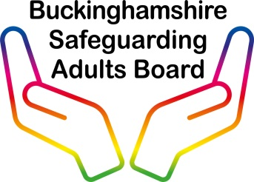

Multi-agency Practice Guidance: Failed Access to Planned Home Visit

This guidance addresses a Safeguarding Adult Review (SAR) recommendation No. 11, “Appropriate escalation procedures are in place and implemented when service users, particularly those at risk of self-neglect, disengage with services” (February 2018).
This recommendation relates to Adult V, a 71 year old male, who lived alone and was known to self-neglect and not engage with once a day package of care. He would remove key from key safe, last attempt at contact with Adult V no response then found dead in home 7 days later.

Who is this guidance for?

- This guidance applies to all staff in Buckinghamshire who may encounter a failed home visit.

- All BSAB partner agencies, organisations and commissioned services must follow their own policies & procedures however they are encouraged to use this document for guidance (as appropriate or if needed).

Definition of ‘Failed Access’

If the staff member is unable to gain access to provide the care / service as arranged and the staff member is unable to establish contact with the service user as a result of either no response or access refused then the visit will be classified as a failed access to home.

These are simply guidelines and organisations/volunteers seeking access to someone’s home must have their own policy and refer to their policy. The flow chart below is merely a prompt to consider action that can be taken should they be unable to gain access for a planned home visit.

Is this situation obviously life threatening or serious? If a person can be seen to be collapsed or in such a condition that warrants extreme concern to their well-being, then emergency services must be called. The person visiting must make an immediate assessment as to whether this is a serious / life threatening situation and act immediately (dial 999).

Non-Urgent Indicators and actions

- You must allow time for people to get to the front door and check whether they can hear the bell/door knocker
- Check the address is correct
- Check windows, are the curtains closed?
- Call through letterbox, telephone/text the person
- Have bins been recently emptied?
- If staff cannot see the individual they should then try to telephone the person.
- Is there evidence of stacked up mail?
- Consider contacting the person’s next of kin or identified contact person.
- Consider approaching the neighbours.
- Contact manager for more information, i.e. was the appointment cancelled, is the person in hospital, has the appointment been re arranged?
- All actions must be clearly recorded in accordance with your organisation’s best practice recording standards.

The graph below has been adopted from the BHT (Buckinghamshire Healthcare NHS Trust).
Please note - if you are concerned that there is no sign of life, you must act immediately and call 999!

