The Mental Capacity Act 2005
Deprivation of Liberty Safeguards and you
Easy read

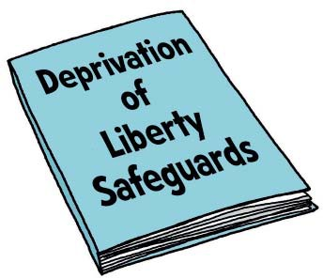
This is an Easy Read booklet about the

Deprivation of Liberty Safeguards.

There are some difﬁcult words in this booklet.

There is a list of these words and what they mean on pages 21 and 22.

These words are in blue letters in the booklet.

You may like to have someone to support you when you look at this booklet.

What is in this booklet?

What is the Mental Capacity Act? 2
Why have we written the Deprivation of Liberty Safeguards? . 5 Why do we need the Deprivation of Liberty Safeguards? 8
What is a deprivation of liberty? 10
When will the Deprivation of Liberty Safeguards be used? 12
What happens if you are being deprived of your liberty? 14
What will happen after the Best Interests Assessor’s report? 16
What will happen if I get Deprivation of Liberty Safeguards? 18
What the words mean 21
How to ﬁnd out more 23

What is the Mental Capacity Act?

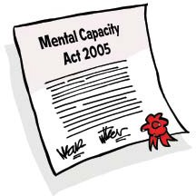
The Mental Capacity Act is a law about making decisions and what to do when people cannot make some decisions for themselves. The Deprivation of Liberty Safeguards are part of the Mental Capacity Act 2005.
This applies to anyone aged 16 years old or over.

When people cannot make a decision for themselves, this is called lacking capacity.

The Mental Capacity Act tells other people how to ﬁnd out if you can make your own decisions.

You might be able to make some decisions, but not able to make other decisions.

People will need to ﬁnd out:
- which decisions you can make on your own

- which decisions you might need some help with, and

- which decisions you cannot make yourself.

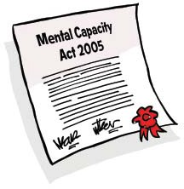
The Mental Capacity Act tells people how to help you to make decisions for yourself, if you can.

The Mental Capacity Act tells people what to do if you cannot make some of your own decisions (if you are lacking capacity).

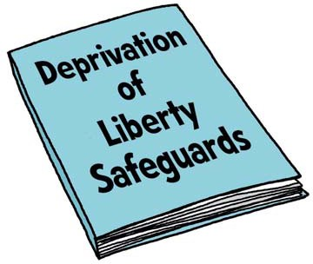
The Deprivation of Liberty Safeguards only apply to people who are lacking capacity.

If you want to know more about the Mental Capacity Act:
- You can read a booklet from
the Ofﬁce of the Public Guardian called Making decisions:
an easy read guide
www.publicguardian.gov.uk/ docs/making-decisions­ opg605-1207.pdf
- You can watch a DVD from the Home Farm Trust called The Mental Capacity
Act 2005 Explained www.hft.org.uk

Why have we written the Deprivation of Liberty Safeguards?

Sometimes people need treatment or care from people like doctors and
nurses or care workers. People who are staying in a hospital or living in a care home should be treated or cared for
in a way that means they are safe. They should be free to do the things they want to do.

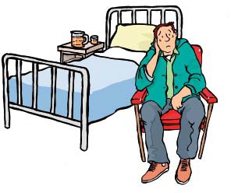
In 1997 a man with autism and learning disabilities was being cared for in a hospital called Bournewood.
Because of his learning disability the man was not able to make the decision about whether he should stay in hospital or go home.

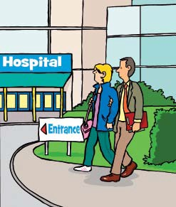
His carers thought the man was not free to do all the things he wanted to do. His carers wanted him to come home.

The hospital did not agree with the carers as the staff believed the man needed to be in hospital to get the care he needed.

So the carers asked an important court in Europe to decide who was right.

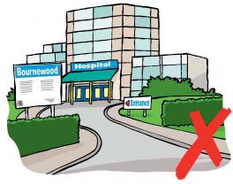
The court agreed with the carers and said the hospital was wrong. They said the hospital had broken the law because the man had had his liberty taken away without any safeguards. This court case was called HL v the UK (often called Bournewood).

The Government decided that it did not want this to happen again to
other people.

The Government has made new rules to make sure that people can be cared for or treated in a way that is right.
These rules are called the Mental Capacity Act 2005 Deprivation of Liberty Safeguards.

Why do we need the Deprivation of Liberty Safeguards?

Sometimes you may need treatment or care from people like doctors and
nurses or care workers if you are staying in a hospital or living in a care home.

People who are lacking capacity need extra protection.

You should be treated or cared for in a way that means you are safe and are free to do the things you want to do.

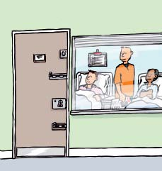
If you are stopped from doing the things you want all the time, this is called being deprived of your liberty. Sometimes people having treatment or care might be deprived of their liberty to keep
them safe.

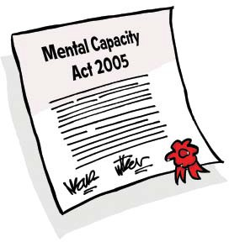
If this happened to you it would have to be in your best interests. People would have to think very carefully about the decisions they make for you, to make sure those decisions are good for you. (You can ﬁnd out more about what this means in the Mental Capacity Act.)

If you are deprived of your liberty you need special protection called safeguards to make sure you are looked after properly and are kept safe. The Deprivation of Liberty Safeguards are the way to give you the special protection you need.

What is a deprivation of liberty?

Liberty means being free to do the things you want to do, when you want to do them.

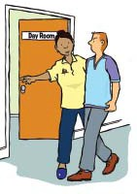
There is no list of what a deprivation of liberty is, but examples include:
- Staff in a care home or hospital having control over all of the decisions in your life

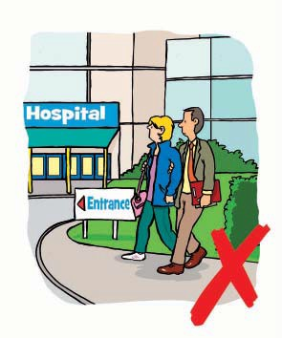
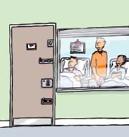
- Not being allowed to leave the hospital where you are staying or the care home where you live

- Your family, carers or friends not being allowed to come and see you.

Deprivation of liberty is about:
  - The way that other people care for you and treat you

  - The way you feel about the way that people care for you and treat you

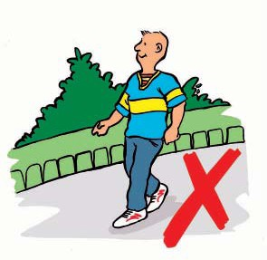
  - The way that the people who care for you and treat you can stop you doing all the things you enjoy.

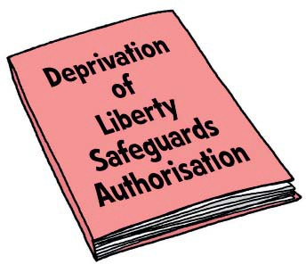
If you are stopped from doing the things you want all the time in a hospital or care home, this is called being deprived of your liberty. If you are being cared for and treated in this way you must have a special agreement called a Deprivation of Liberty Safeguards Authorisation
to keep you safe.

This is the law.

When will the Deprivation
of Liberty Safeguards be used?

The Deprivation of Liberty Safeguards are for people who cannot make a decision about the way they are being treated or cared for in a hospital or care home, where other people are having to make this decision for them.

Deprivation of Liberty Safeguards are the way to give you the protection you need when you are being cared for or treated in ways that deprive you of your liberty.

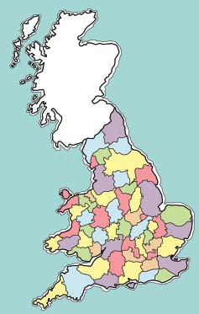
The Deprivation of Liberty Safeguards are for:
- people living in England or Wales

  - people who are 18 years old or older

  - people who have a mental disorder such as dementia (a sort of mental illness) or a learning disability

  - people who live in a care home or are staying in hospital, who are lacking capacity to agree to be
there. (The people need to be there to get the treatment or care that will protect them from harm in their best interests.)

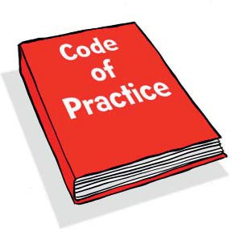
What happens if you are being deprived of your liberty?

There is a book of rules that explains what should happen. This is called the Code of Practice and tells the people involved what to do.

The Code of Practice says that the people who are caring for or treating you are called the managing authority. If the managing authority thinks they need to deprive you of your liberty, they must make sure they are not breaking the law.

The managing authority must write to something called the supervisory
body (your local council or health trust) to tell them that they think you need Deprivation of Liberty Safeguards.

The Code of Practice says the supervisory body must decide if you need Deprivation of Liberty Safeguards. They will do this by arranging at least
2 people to check how you are being treated or cared for. These people are called assessors.

One assessor is called the Best Interests Assessor. The Best Interests Assessor will be a person who does not work with you.

The Best Interests Assessor will write a report to tell the supervisory body if you need a Deprivation of Liberty Safeguards Authorisation and for how long this should be.

The Deprivation of Liberty Safeguards should be for as short a time as possible and never for longer than a year.

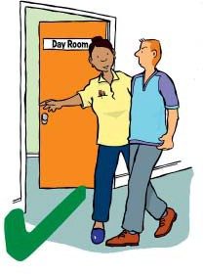
What will happen after the Best Interests Assessor’s report?

The Best Interests Assessor’s report might say you are being deprived of your liberty and that this is in your
best interests.

Then the supervisory body will write to the managing authority to tell them this and ask them to explain this to you. You will get a Deprivation of Liberty Safeguards Authorisation to make sure you are safe.

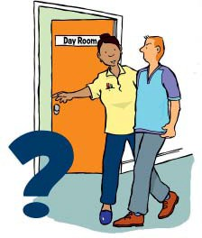
Or the report might say you are being deprived of your liberty but some changes are needed. For example, changes to the way you are cared for.

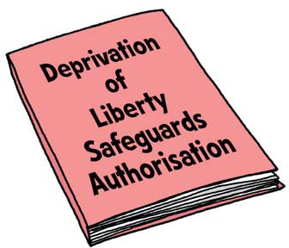
Then the supervisory body will write to the managing authority to tell them this and ask them to explain this to you. The changes must happen.
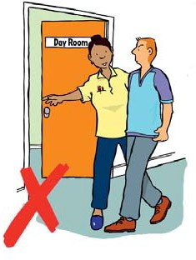
You will get a Deprivation of Liberty Safeguards Authorisation to make sure you are safe.

Or the report might say you should not be deprived of your liberty.

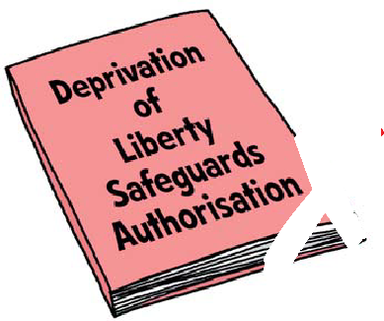Then the supervisory body will write to the managing authority to tell them this and ask them to explain this to you. You must not be deprived of your liberty any more, so you will not need a Deprivation of Liberty Safeguards Authorisation.

What will happen if I get Deprivation of Liberty Safeguards?

Everyone who has a Deprivation of Liberty Safeguards Authorisation must have a representative. The supervisory body will make sure you get a representative.

A representative is a person who does not work with you. They visit you and check you are looked after in a way that means you are safe. Your representative could be a member of your family or
a friend.

If you or anyone else is unhappy about you being deprived of your liberty, they can ask for a review. A review is a check to make sure that you are being treated in the right way.

You or your representative or your
managing authority can ask for
a review. There will also be a review if your situation changes.

If you or your representative disagree about you being deprived of your liberty, you can ask a special court called the Court of Protection to decide whether you should be deprived of your liberty or not.

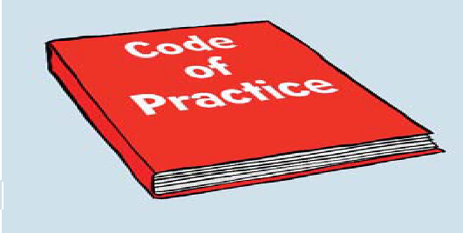
How to ﬁnd out more about the Deprivation of Liberty Safeguards
There is a rule book about the Deprivation of Liberty Safeguards called the Code of Practice. Everybody caring for you has to follow these rules. The Code of Practice tells you more about the Deprivation of Liberty Safeguards. You can see it at:

www.dh.gov.uk/en/Publicationsandstatistics/ Publications/PublicationsPolicyAndGuidance/ DH_085476

How to appeal against being deprived of your liberty under the Deprivation of Liberty Safeguards
If you (or your representative) are reading this because you are deprived of your liberty, you can contact the Court of Protection at:
The Court of Protection Customer Services Archway Tower
2 Junction Road London N19 5SZ

Telephone: 0845 330 2900
(Phone lines are open from 9am–5pm) Fax: 020 7664 7551

Email: customerservices@publicguardian.gsi.gov.uk

What the words mean

assessor | Someone who checks for the supervisory body that a person is being treated or cared for in the right way
autism | Someone with autism ﬁnds it hard to relate to other people
Best Interests Assessor | The person who writes a report to tell the supervisory body if someone needs a Deprivation of Liberty Safeguards Authorisation
Code of Practice | A rule book about the Deprivation of Liberty Safeguards
Court of Protection | A special court which decides whether or not a person should be deprived of their liberty
deprivation of liberty | Stopping someone from doing the things they want all the time in a hospital or care home
Deprivation of Liberty Safeguards | Rules about giving people the special protection they need in a hospital or care home
Deprivation of Liberty Safeguards Authorisation | A special agreement which says a person can be deprived of their liberty
lacking capacity | When people cannot make a decision for themselves
managing authority | The people who are in charge of the care or treatment of someone who is lacking capacity

What the words mean

Mental Capacity Act | A law about making decisions and what to do when people cannot make some decisions for themselves
Mental Capacity Act 2005  Deprivation of Liberty Safeguards | Rules to make sure that people who are lacking capacity can be cared for or treated in a way that is right and keeps the law
representative | A person who visits someone who is lacking capacity to check they are looked after in a way that means they are safe
review | A check to make sure that a person in a hospital or a care home is being treated in the right way
safeguard | Something that keeps a person safe
supervisory body | The people who decide if someone needs Deprivation of Liberty Safeguards

How to ﬁnd out more
If you want more copies of this booklet
you can:
  - Telephone 0300 123 1002

  - Visit www.orderline.dh.gov.uk

  - Email dh@prolog.uk.com

Write to:

DH Publications Orderline PO Box 777

London SE1 6XH

Please tell us the Easy Read version order number 294075 when you contact us

Or you can read this booklet and ﬁnd out more on our website at: www.dh.gov.uk/en/SocialCare/ Deliveringadultsocialcare/ MentalCapacity/ MentalCapacityActDeprivationof LibertySafeguards/index.htm

© Crown copyright 2009
Produced by COI for the Department of Health 294075 1p March 2009

