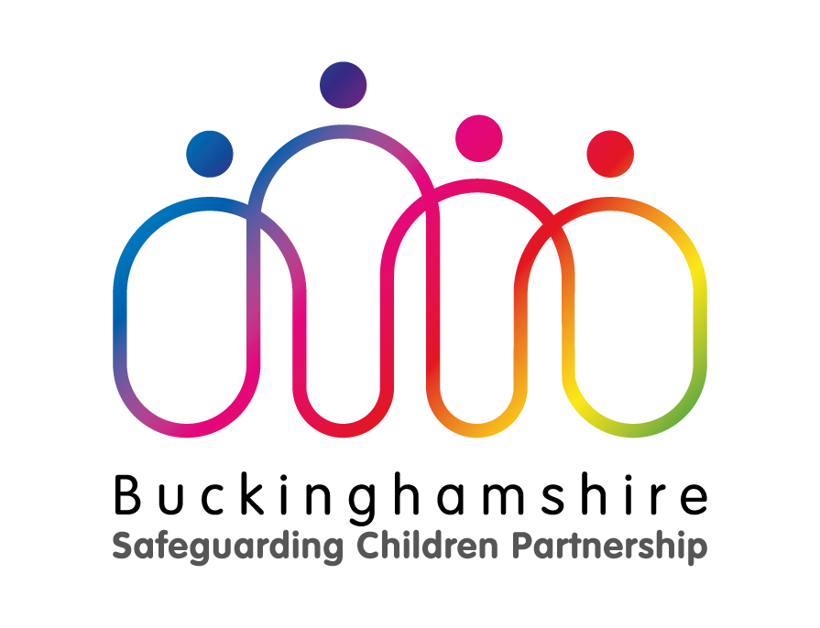

Serious Case Review

Child AA

Summary Report

Mark Jowett, Independent Author

Introduction
Buckinghamshire Safeguarding Children Board (now known as Buckinghamshire Safeguarding Children Partnership) decided to undertake a Serious Case Review in relation to the death of Child AA in 2019.
At the time of death Child AA had been known to a number of agencies.

Process for conducting the review
Buckinghamshire Safeguarding Children Partnership commissioned Mark Jowett to author the report. Mark Jowett is fully independent of Buckinghamshire Safeguarding Children Partnership. In addition, a multi-agency Serious Case Review Panel was established to oversee the Serious Case Review. No professionals who formed part of the panel had any operational responsibility for agency working in relation to Child AA.

Alongside the Serious Case Review, NHS England commissioned a Mental Health Homicide Review, and that report informs some of the learning in this report. The Mental Health Homicide Review followed a Comprehensive Root Cause Analysis Investigation Report (Oxford Health NHS Foundation Trust) which reviewed the care that Child AA’s mother received from Oxford Health NHS Foundation Trust.

In terms of methodology which conforms with statutory guidance, the Panel planned to undertake the review by gathering agency chronologies and analysis of learning, and then conducting a multi-agency workshop whereby members of the Panel shared learning from their specific agencies. Unfortunately, it was not possible to hold a frontline practitioner and manager event as anticipated, as some key staff members remained very distressed following the tragic death of Child AA. However, in order to understand perspectives in relation to learning, key adult mental health professionals were interviewed as part of an internal review and the wider the Mental Health Homicide Review. In addition, the author of the Serious Case Review and the Mental Health Homicide Review jointly interviewed the Children’s Social Care frontline manager. The Serious Case Review author also spoke with the social worker who had been allocated to Child AA. Finally, the Panel reconvened to consider the draft of the Serious Case Review report, with recommendations for multi-agency learning discussed.

Whilst the Panel identified that critical events took place over a period of 4 months, the review considered a wider timeframe over 2 years in order to capture any previous information that may be helpful in terms of providing a wider context to the family history and inform learning.

The Review considered the detailed, chronological history of Child AA and the family’s interaction with services over this period, as well as a detailed review of key episodes, informed by the multi-agency chronologies and analysis and the author’s interviews with key personnel.

Good Practice
The focus of a Review is to learn and improve services. As such, it is important to learn from examples of good practice that support good outcomes for children. Good practice from a number of agencies and professionals was identified during the course of the Review including:

- The allocated social worker identified that the mother required debt counselling and sign-posted her to relevant services. The social worker also offered the mother ongoing support via Child in Need or Early Help.
- SCAS, Police and Children’s Social Care Out of Hours liaised and responded quickly to a family member’s call during the critical period.
- The Children’s Social Care team attempted to encourage the GP to make the referral to the Adult Mental Health Team and showed tenacity in getting the Adult Mental Health Team to respond urgently.
- The Adult Mental Health Team responded quickly and made several attempts to engage the mother. This included an un-announced visit.
- The Adult Mental Health Team arranged an assessment of the mother as soon as the mother was willing.
- The Mental Health Assessment was carried out by experienced practitioners and was viewed by the Independent Mental Health Homicide Review to be thorough and of good quality.
- The Housing Association offered the mother good support with her debt management and housing issues, and this included helping her to successfully apply for a Homeless Prevention Fund.

Conclusion
The Serious Case Review concluded that the death of Child AA could not have been predicted prior to or at the point of the Mental Health Assessment during the critical period. Whilst no specific acts or omissions were identified by the Review as leading directly to the death of Child AA, there are some aspects in terms of joint working and sharing of information that could have been stronger.

A full mental health assessment conducted by an experienced team was completed during the critical period. This did not elicit any evidence that the mother was suffering from a mental disorder. The Mother did not have any formal psychiatric history, and on the basis of this information and within the context of the earlier Children’s Social Care assessment and information, the view of Children’s Social Care was that there was no evidence of risk to Child AA.

The view of the Mental Health Homicide Review was that the NHS clinicians fulfilled their responsibilities and completed a good and thorough assessment of the mother.

It is clear from accounts of family members that they were seeing some evidence of mental health symptoms in the mother, though not all of this information was known to professionals until after Child AA’s death. If the mother had been experiencing psychotic symptoms at the time, then she was adept at hiding them and the experienced NHS clinicians were not able to find evidence of what appears may have been a psychotic state.

The Serious Case Review concluded that whilst the tragic incident which resulted in the death of Child AA could not have been predicted and no blame should be attributed, improved system wide communication and assessment between professionals, with greater involvement of the family would have been valuable.

Recommendations
The Review made the following recommendations which were accepted by the Buckinghamshire Safeguarding Children Partnership:

Buckinghamshire Safeguarding Children Partnership to monitor the implementation of actions from single agency action plans. This includes the actions and recommendations detailed in the Mental Health Homicide Review.

The Serious Case Review Panel makes the following multi-agency recommendations to Buckinghamshire Safeguarding Children Partnership:

Whole family approach
- Buckinghamshire Safeguarding Children Partnership to work with Buckinghamshire Safeguarding Adults Board to oversee the review of approaches to the assessment and interventions with whole families where the criteria for a referral to Adult Services is met.
Promote learning
- Buckinghamshire Safeguarding Children Partnership to promote the learning from this review across relevant partner agencies, and to gain evidence in relation to dissemination and embedding of learning. Buckinghamshire Safeguarding Children Partnership to hold a multi-agency workshop on the issues coming out of the Serious Case Review in order to increase working relationships and practitioner awareness.
Training
- Buckinghamshire Safeguarding Children Partnership to work with Buckinghamshire Safeguarding Adults Board in overseeing a review of how to maximise practitioners’ skills in the assessment of parental mental health and the impact on children. This should include an audit of single and joint training with a view to strengthening arrangements across agencies.
Policies & procedures
- Buckinghamshire Safeguarding Children Partnership to oversee the review of multi-agency policies, procedures and protocols relating to parenting capacity and mental illness, to ensure learning from this Serious Case Review is included.
- Information sharing
Buckinghamshire Safeguarding Children Partnership to work with Buckinghamshire Safeguarding Adults Board in overseeing the review and update of its information sharing code of practice. This should include the value of working closely with extended family members. Information should be sought from extended families and carers to inform assessments as a matter of course unless there are clear reasons why it is not appropriate to do so.

Mark Jowett is an independent Safeguarding Consultant and has extensive experience in Children’s Services and Local Safeguarding Children Boards and has authored numerous Reviews including Serious Case Review.
Mental Health Homicide Review: A Mental Health Homicide Review was commissioned by NHS England and authored by Anne Richardson. The purpose is to review the care and treatment received by the patient so that the NHS can be clear what (if anything) went wrong with the care of the patient; minimise the possibility of reoccurrence of similar events; and make recommendations for the delivery of health services in the future.
Working Together to Safeguard Children expects case reviews to be conducted in a way that; recognises the complex circumstances in which professionals work together; seeks to understand precisely who did what and the underlying reasons that led individuals and organisations to act as they did ; seeks to understand practice from the viewpoint of the individuals and organisations involved at the time rather than using hindsight; is transparent about the way data is collected and analysed; and makes use of relevant research and case evidence to inform findings.
Agencies that have contributed to this review are; Oxford Health NHS Foundation Trust, Buckingham Children’s Social Care, Thames Valley Police, Buckinghamshire Health Care Trust, Buckingham Clinical Commissioning Group, Hightown Housing Association, Oxford Health NHS Foundation Trust, South Central Ambulance Service, Frimley Health NHS Foundation Trust.

