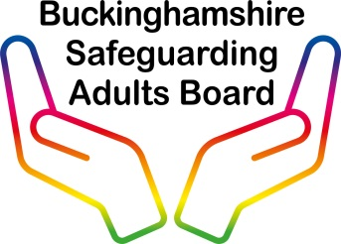

Buckinghamshire
Complex Case Panel

Terms of Reference

Contents

- Introduction
- Membership of the Complex Case Panel
- Eligibility
- Information Sharing
- The Complex Case Panel Process
- Evaluation

- Introduction

The Complex Case Panel aims to support adults who meet the Care Act safeguarding criteria, and who are resident in Buckinghamshire. The Complex Case Panel provides professionals with an opportunity to seek multi-agency advice. In exceptional circumstances, the Chair can request that a particular adult’s case must be brought back for a further discussion with the panel.

The Care Act 2014 and its accompanying Care and Support Statutory Guidance defines the safeguarding duty as applying to an adult who meets the following criteria:

- Has needs for care and support, whether or not the local authority is meeting those needs; and is
- Experiencing abuse or neglect or at risk of abuse or neglect
- As a result of their care and support needs, is unable to protect themselves from either the risk of, or the experience of, abuse or neglect.

The Complex Case Panel is a multi-agency panel to support practitioners and service users where aspects of an individual’s lifestyle are potentially, or actually, harmful to their wellbeing, and aims to be beneficial in the following ways:

  - to identify risk at an earlier opportunity
  - to allow consideration of a variety of options for supporting individuals
  - to provide improved support for practitioners
  - to identify a proportionate, coordinated, effective and timely response
  - to secure improved outcomes for the adult with care and support needs
  - to create a wider understanding amongst partner agencies of the nature of care and support needs in Buckinghamshire, and the services available to meet these needs

- Membership of the Complex Case Panel
The Panel will appoint a Chair and a Vice Chair from its membership, and will review these appointments on an annual basis. Attendees at the Complex Case Panel meeting will include nominated representatives and a deputy from each of the following:
- Adult Social Care
- Oxford Health clinicians and/or mental health social care leads
- Buckinghamshire Council Housing and Regulatory Standards such as Environmental Health
- Registered Social Landlords
- Buckinghamshire Council Quality, Standards and Practice
- Relevant Safeguarding Leads
- One Recovery Bucks
- Thames Valley Police
- Bucks Fire and Rescue
- Attendees who are relevant to the needs of the individual
If the relevant and appropriate professional representation is not in attendance, then the panel will not be able to go ahead and will need to rescheduled. Relevance will relate to the cases presented on the day and the Chair will make the decision on this on a panel-by-panel basis.
Where a key member is not able to attend, then their nominated deputy will assume the responsibility for attendance and pre-panel preparation (see section 5).

- Eligibility
The Complex Case Panel is a forum to hear:
- cases where it is believed that early identification and coordination of available multi-agency support may reduce or prevent a likely escalation of risk to a vulnerable adult

- those cases where previous attempts to provide support have exhausted all other multi-agency options, and the individual is believed to be:
- engaging in behaviours which present a high risk to themselves or others
- not engaging with a network of ongoing support
- at risk of severe harm or death
- a significant risk to other people
- in need of care and support but does not meet statutory social care

Please note if the individual lacks the mental capacity in relation to understanding the consequences of their actions; this will be addressed via a parallel process in the Court of Protection.

- Information Sharing

- Attendees will be required to sign an information sharing agreement
- An individual’s consent for their information to be shared with the Panel will be evidenced by completion of the required referral form by the allocated practitioner presenting the case
- Where consent is not sought or obtained, clear reasons will be documented in the person’s record and the minutes of any resulting meetings. These will need to relate to one of the following:
- prejudice the prevention, detection or prosecution of a serious crime - this is likely to cover most criminal offences relating to children and adults
- lead to an unjustified delay in making enquiries about allegations of significant harm to an individual.

.

- The Process
The decision to progress a case to the Complex Case Panel will be made by relevant senior managers, and this will be evidenced by completion of the required referral form. All organisations must ensure that multi-disciplinary meetings have been convened to resolve issues as part of business as usual (BAU) working before presenting the case to panel.
The lead practitioner for the referral will complete the referral form and submit the case to the Complex Case Panel. This should be emailed to BSABcomplexcasepanel@buckinghamshire.gov.uk
The list for new referrals will be closed ten working days before the date of panel, and any referrals received after that time will be deferred to the next meeting. The Complex Case Panel will normally meet on a monthly basis.
All attendees will be sent a list of cases for discussion and required to submit back into the BSAB whether this person is known to their agency. If they are known, panel members will be asked to complete a short summary of significant events and information relating to the presenting needs.
Panel members will be sent a summary of all returns received five working days before the date of the panel. This will enable the focus of the meeting to be on solutions and planning.

All agencies involved with the individual retain responsibility for case management and coordinating the actions/outcomes linked to the person’s care and support plan. At no time will the Complex Case Panel assume responsibility for this as a governance structure.

If information received by any agency indicates an escalation of risk, appropriate action by the lead organisation will need to be taken to safeguard the individual in accordance with Buckinghamshire Safeguarding Procedures. Please see

https://www.buckssafeguarding.org.uk/adultsboard/report-a-concern/

Information received into the Complex Case Panel, combined with multi-agency discussion, will result in multi-agency recommendations which will be recorded in an action plan for the lead professional working with the adult to coordinate an appropriate course of action.

The focus of the meeting will be to agree recommendations, record them in a measurable plan and agree a lead professional. Outcomes will also be reviewed by the Panel in accordance with set timescales.

- Evaluation
The Buckinghamshire Safeguarding Adults Board will seek assurance on a quarterly basis that the Complex Case Panel is effective and is adhering to its Terms of Reference.

The Complex Case Panel will report against the following measures:

- Attendance of multi-agency partners at panel
- Number of referrals to the Complex Case Panel
- Referring agency
- Contribution of data gathering prior to panel
- Outcome of cases entering the Complex Case Panel
- Repeat contact rate into the Complex Case Panel
- Experience of professionals participating in the Complex Case Panel
- Experience of individuals or their representatives
- Qualitative review of data and dip sampling of practice
- Emerging learning and development needs identified

Appendix 1.0

Draft Agenda
- Welcome and Introduction, to include:
  - Apologies
  - Roles of agencies/professionals/individuals represented

- New Referrals, to include:

- Details of the adult at risk / Pen picture of case
- Actions already taken
- MCA
- Consent
- Risk Indicators Discussion - Agree severity of risks identified utilising the matrices below
- Action Planning and Support Strategies
- Risk Enablement Planning
- Identify Lead Professional
- Review – Frequency of Review

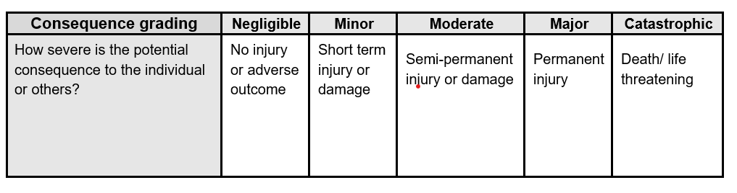
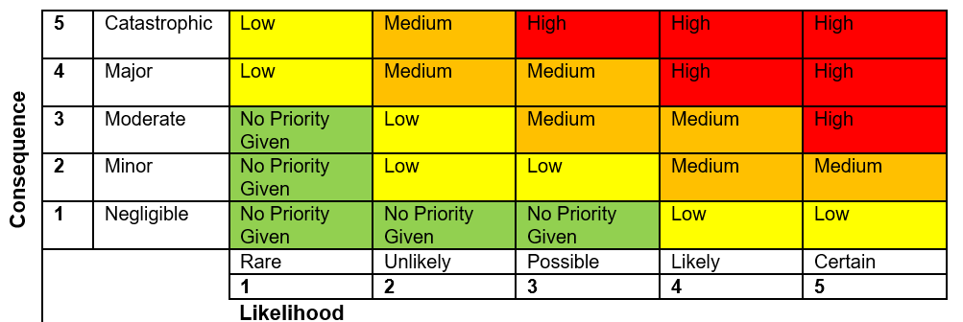

- Revisit Past Referrals, to include:

- review of progress
- consideration of further actions/support required
- decision as to whether the case needs to be brought back for further review or can be closed to panel

- Past Referrals – Impact Statements

- Any Other Business

- Dates of Future Meetings

